
Health Education England’s Technology Enhanced Learning Team’s Specialty Training Gaps project
Extended Reality (XR) Hub – Virtual Reality (HTC Vive Focus 3) Pilot

- What is the Extended Reality (XR) Hub?

HEE TEL has created a library of specific immersive learning technologies called the extended reality (XR) Hub. The XR Hub includes a range of augmented, virtual and mixed reality technologies and associated software applications that offer innovative opportunities to educate and train the health and care workforce. These devices will be made available on a fixed term loan basis to selected NHS organisations in the context of the national postgraduate medical specialty training recovery programme. Evaluation of this approach and feedback from end users on the potential wider benefits of these technologies will inform the future development of the XR Hub and strengthen guidance available to NHS organisations and educational commissioners regarding further local investment.
This information sheet provides further details of the pilot project that addresses offering access to one of the technologies included within the XR Hub, namely the HTC Vive Focus 3 headset and associated software applications.

- What is an HTC Vive Focus 3?

The HTC Vive Focus 3 is a virtual reality (VR) headset which when placed over the face isolates the wearer from external sounds and vision, creating a fully immersive environment. It comes installed with a wide range of software that can create educational and wellbeing experiences.

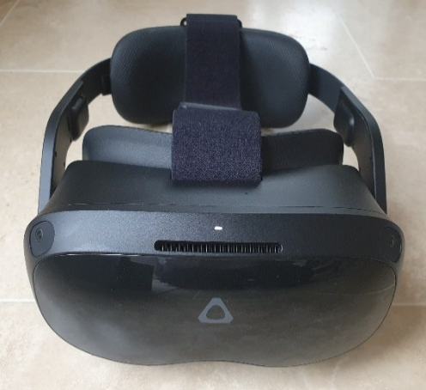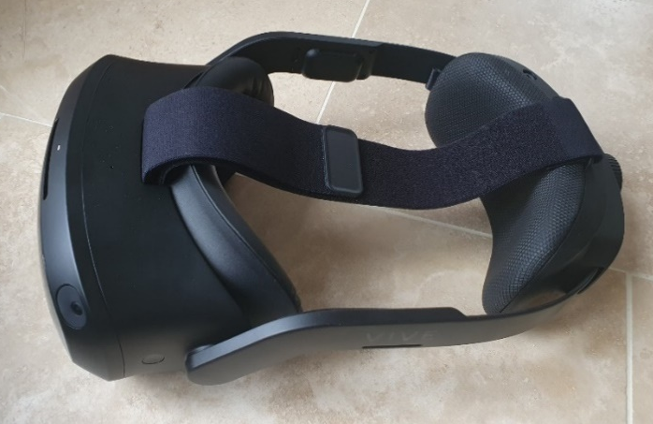
Photos: Front and top profiles of HTC Vive Focus 3 headset showing front facing cameras, active light and fan outlet, headset strap, face and rear gaskets.

Additional information on the HTC Vive Focus 3 can be accessed on the HTC Vive Focus 3 website.

- How can an HTC Vive Focus 3 be used in health and care education?

The HTC Vive Focus 3 is a virtual reality headset which, when coupled with software solutions, creates a fully immersive environment.
Virtual reality devices are ideally suited to one-to-one and group teaching. They are able to display virtual reality content, such as virtual tours of physical locations which are hard to access (eg histopathology labs); demonstrating procedures in high definition (eg surgical techniques); teambuilding scenarios and much more.
The devices can also be useful in supporting wellbeing of staff by reproducing relaxing and therapeutic environments.

- What is the Virtual Reality (HTC Vive Focus 3) pilot?
This pilot is a six-week test period being offered to each of the HEE regions to introduce pilot sites to the concept and potential uses of virtual reality to support education and training in health and care.

Each site that is accepted to take part will receive 5 headsets and some supporting resources to help explore their potential usefulness in an educational context. Some specific software will be pre-loaded to enable a number of functions to be offered including the following:

JoinXR – a meeting environment for professional use and for bringing in 3D models to the collaborative space.

Medical Realities – a library of immersive video content including 360 videos of surgery and virtual Objective Structured Clinical Examinations (OSCEs).

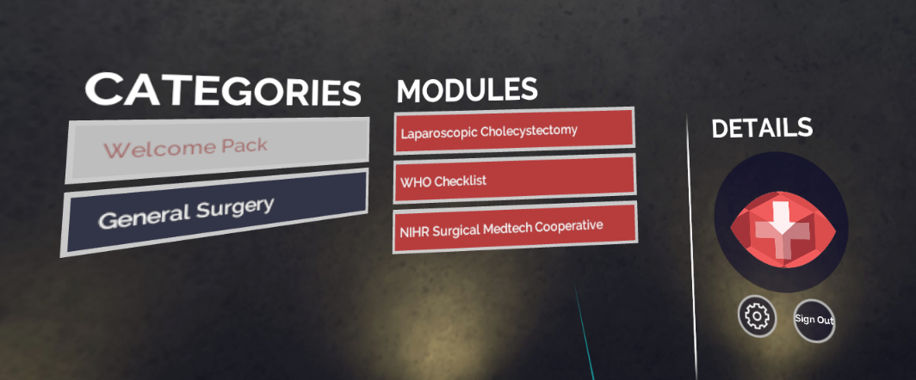

Vive Sync – all-in-one meeting and collaboration solution for VR

- What is the purpose of the pilot?
The exercise is intended to check that the systems and processes (including logistics) for identifying end users and deploying equipment to them is fit for purpose. It will also allow us to test and improve the guidance and other support services that local users can access to enable use of the technology to be explored in a local context.

- What do I need to do to take part in the pilot?

Expressions of interest to take part in the pilot are being noted by nominated regional HEE representatives – see question 19.

Your representative will share with you the documentation that has to be completed in advance of being selected. This documentation is to help ensure your organisation has an appropriate IT infrastructure to use these devices. We also ask you to nominate who will be responsible for the equipment whilst on site and details about who will access these devices.

- What is in the HTC Vive Focus 3 package?

The pilot package includes the following:
  - 5 x HTC Vive Focus 3 headsets
  - 5 x spare batteries (on request) if extra batteries required
  - 5 x cables for connecting the devices to a laptop (on request) if cables required
Specific software is installed and ready to go (JoinXR, Medical Realities and Vive Sync).

- When does the pilot start and finish?
Each individual pilot will start once a nominated site has been selected and approved by the regional office and HEE’s national TEL team. The pilot will be continued for a period of 6 weeks from the delivery to nominated site. At the end of 6 weeks, the devices will be collected from the delivery location. The HEE TEL team will ask you to complete some short feedback surveys during the pilot to provide information to help improve the future implementation of the XR Hubs as a sustainable service.

Under specific circumstances the 6 week loan period may be extended to allow an agreed project to be continued through to completion. This will be through agreement of your regional team and national TEL representatives’

- What are the feedback surveys?

There will be 3 short surveys to complete by each selected pilot site during the loan period. This will document your experience of the logistics and support services and information made available to participate in the pilot. At the conclusion we may also ask you to help us produce a short case study to summarise key learning points that will help future sites understand the potential benefits and requirements for accessing and making us of the technologies described.

- What documents do I need to complete to take part in the Virtual Reality pilot?

To take part, you will need to complete the following documents:

  - TEL Readiness Assessment (see section 10, 11 and 12)
  - Loan agreement (see section 13)
  - Schedule 1(services) document (see section 14)
  - Schedule 2 (equipment) document (see section 15)

- What is the Technology Enhanced Learning (TEL) Readiness Assessment?

The TEL Readiness Assessment is a broader piece of work being undertaken by the Technology Enhanced Learning team. Led by the Supporting TEL team, the assessment helps organisations to identify their ‘TEL maturity score’ and, where gaps are identified, offer support to enable them to become technology enhanced learning ready. A number of questions in the TEL Readiness Assessment are particularly relevant to the use of specific immersive learning technologies contained within the XR Hubs.

If you wish to find out more or require assistance with the survey the Supporting TEL team can be contacted at: tel@hee.nhs.uk.

- Which parts of the TEL Readiness Assessment do I need to complete to take part in the pilot?

We would like you to complete ALL parts of the TEL Readiness Assessment to ensure that your organisation is ready to make best use of different types of XR device as they become available for wider use. However, for the purposes of the HTC Focus Vive 3 pilot, you will need to complete the following sections and questions.

TEL Readiness Assessment Section | Question
2. Connectivity  Does your organisation make any 5G Mobile Networks available on any of your sites? | Access to 4G/5G Internet?
2. Connectivity  What is the average bandwidth and speed of the main network for education purposes in the organisation? | WI-FI/network speed above 5mbps? Speed test.
4. Support  What level of local technical support is available for maintaining equipment? | Will there be adequate technical support to use this equipment?
5. Provision  Access can be reliant on having a software tenant (the organisation will need to support this). | Do you have access to your own tenant, such as Office 365, Facebook, Google or other?
5. Provision | Will there be adequate storage and security for devices?
9. Governance | IG – does your IG team provisionally support the use of immersive technologies?

- What happens if our organisation is not suitable for these devices based on the TEL Readiness Assessment?

If the TEL Readiness Assessment identifies that your location does not currently meet the minimum criteria, you will be unlikely to be eligible take part in this pilot. However, you will be contacted by the Supporting TEL team after they have reviewed your assessment survey if this is the case. This will provide you with guidance and support to take the steps necessary to address the issues identified.

For support with this, please contact: tel@hee.nhs.uk.

- What is the loan agreement?

HEE has agreed to loan specified immersive learning technologies (from the XR Hub) free of charge to end user organisations (the Provider) in return for the end users providing feedback to HEE by way of responding to brief surveys on the functionality of this process and reporting progress with achieving specified educational outcomes in the form of case studies or other publications.

The loan agreement is the contract between HEE and the end user organisation (the Provider) to underpin this arrangement. This agreement has been developed by the HEE National Contracts Management Team to clarify responsibility for equipment whilst on loan. For the purpose of this pilot, we anticipate this will be the Director of Medical Education or a colleague in similar role.

- What is the Schedule 1 (Services) document?

This document links to the overarching Loan Agreement and is intended to provide some further information detailing a number of responsibilities pertinent to the equipment loaned, and a succinct outline of the educational purpose or project that the equipment is being used to support. This will include a description of the educational aims, intended learning outcomes and learners who will be benefiting from the project.

- What is the Schedule 2 (Equipment) document?

This document describes the equipment in more detail that is being loaned to the end user organisation. It also identifies specific nominated contacts within the end user organisation who will be responsible for its receipt and return as well as its care and use whilst on site.

- Where do I go for support during the pilot?

Further information about the support functions, services and specific guidance resources being developed by HEE TEL for all resources on the XR Hub is available on the Learning Hub,

A dedicated support service offering technical assistance and troubleshooting advice can also be accessed by email TEL@hee.nhs.uk .

- Can I get additional equipment as part of the Virtual Reality pilot?

The pilot is designed for HEE to test its processes and procedures for deployment, local adoption and return of equipment. This specific pilot is being limited to HTC Vive Focus 3 devices only. Separate pilots are being undertaken for HoloLens and other immersive learning technologies within the HEE TEL XR Hubs. The collated feedback from each pilot will inform arrangements for future access and longer term loan of technologies from the XR Hubs.

- Who else is taking part in the Virtual Reality pilot?

The pilot has been designed to include one or more sites from each of the 7 HEE regions, within the limits of the number of loan packs that we have available.

- Who do I contact about taking part in the Virtual Reality pilot?

Each of the HEE regions has nominated one or more individuals to act as contacts for this pilot. They are listed below.

East of England | Georgia Winnett  Rowan Burnstein | georgia.winnett@nhs.net  rowan.burnstein@hee.nhs.uk
London | Cleave Gass  Kasia Zawadzka  Larissa Thomas  Lucy Brock | Cleave.gass@hee.nhs.uk  Kasia.zawadzka@hee.nhs.uk  Larissa.Thomas@hee.nhs.uk  Lucy.brock@uclpartners.com
Midlands | Ed Briggs  Usman Ahmed  Natasha Ritchie  Alexander Crichton  Andy Whallett | Edward.Briggs@hee.nhs.uk  usman.ahmed@hee.nhs.uk  natasha.ritchie@hee.nhs.uk  alexander.crichton@hee.nhs.uk  Andy.Whallett@hee.nhs.uk
North East | Katherine Williamson  Andrew Brennan  Richard Bellamy  James Storey | Katherine.Williamson4@nhs.net  Andrew.Brennan@hee.nhs.uk  Richard.Bellamy@hee.nhs.uk  jamesstorey@nhs.net
North West | Pramod Luthra  Jane Fylan  Mark Hellaby | Pramod.Luthra@hee.nhs.uk  Jane.Fylan@hee.nhs.uk  Mark.hellaby@mft.nhs.uk
South East | Rosie Courtney  Ali Bokhari  Helen Higham  Philip Rushton  Andy Buttery | Rosie.Courtney@hee.nhs.uk  ali.bokhari1@nhs.net  helen.higham@ndcn.ox.ac.uk  philip.rushton@hee.nhs.uk  andy.buttery@canterbury.ac.uk
South West | Wai-yee Tse  Dan Freshwater-Turner | wai-yee.tse@nhs.net  dan.freshwater-turner@uhbw.nhs.uk

Relationship Managers Contact Details by Region
Relationship Managers | Region | Email address
Sue Hughes | NW and NEY | Sue.Hughes@hee.nhs.uk
Rozz McDonald | SW and Midlands | Rozz.McDonald@hee.nhs.uk
Iain O'Neill | London and SE | Iain.ONeill@hee.nhs.uk
Sean Bradbury | East of England | XRSupport@hee.nhs.uk

Document Version Information

Document Title | Health Education England’s Technology Enhanced Learning Team’s Specialty Training Gaps project – Extended Reality (XR) Hubs – Virtual Reality (HTC Vive Focus 3) Pilot
Filepath\Filename |  | Format | Comments
SharePoint |  | MS Word

Supporting Documents | Format | Comments

Responsibilities

Classification

Distribution

Ownership

Maintenance

Distribution of Final Version
Copy | Keeper | Area | Purpose | Method
1 | Patricia Howe

2

3

Document Version History
Version No./ Status | Issue Date | Author | Quality Review/ Change Date | Reviewed By | Brief Description of Action/ Changes
0.1 | Dec 2021 | Richard Price |  |  | On SharePoint
0.2 | Jan 2022 | Jamil Choglay |  | Nick Peres  Kyle Goulding  Chris Gay | Added updates to the sections
0.3 | Feb 2022 | Kyle Goulding |  | Nick Peres  Chris Gay  Jamil Choglay | Updated the technical sections
0.4 | Feb 2022 | Chris Gay |  | Chris Gay | Added suggested comments for change.
1.0 | Feb 2022 | Alex Drinkall |  | Jamil Choglay  Tarique Chowdhury | Updated document

