MEDICAL LEADERSHIP DEVELOPMENT TOOL
AUDIT BASED DISCUSSION

This Medical Leadership Development Tool ‘Audit Based Discussion’ aims to enhance your understanding and implementation of clinical audit to improve patient care. Clinical audits are undertaken regularly at various levels of training within postgraduate medical education and in all specialties. However the quality of audits can be variable. This tool allows you to demonstrate achievement of crucial aspects of an effective clinical audit through a peer review exercise and further improvement though feedback. The classical description of a Clinical Audit Cycle is illustrated below (picture source: Wikipedia)

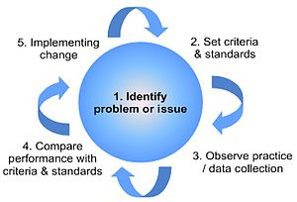

Brief notes for peer assessor giving feedback:

- This discussion is best undertaken at the end of an audit project
- You should be experienced in the use of clinical audit
- One of the important aspects of a good clinical audit project is the identification and management of change. This discussion could either facilitate the identification of which the recommendations made from audit are to be taken forward or to assess the overall impact of such a change if it has already been implemented

MEDICAL LEADERSHIP DEVELOPMENT TOOL
AUDIT BASED DISCUSSION

Name of audit project: | Name of Doctor:
Name of host organisation/practice: | Date:

Please tick the appropriate boxes or mark N/A if not applicable
 | Needs further development | Achieved | Comments
1. Clarity of aims & objectives
2. Relevance to clinical practice
3. Appropriateness of data collection methodology
4. Have the standards been established?
5. Data analysis & presentation of findings
6. Validity of recommendations
7. Implementation of change
8. Closing the loop – re-audit
9. Overall performance

Any aspects of the audit which were especially good?

Any suggestions for improvement and action points?

Name of Doctor presenting: Signature:

Name of peer giving feedback: Signature:

