Grange Hotel
Station Square ∙ Grange-over-Sands ∙ Cumbria ∙ LA11 6EJ
Tel: 01539 533 666

It is very easy to reach the hotel by train as the station is within 1 minutes walk

Take exit 36 from the M6, follow the signs to Barrow (A590) and take the B5277 to Grange-over-Sands. The Grange Hotel is on the right just before the Railway Station as you enter Grange.

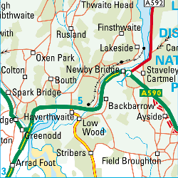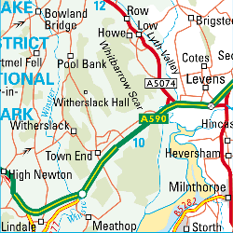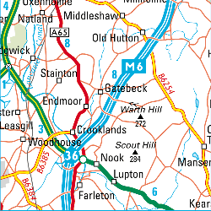
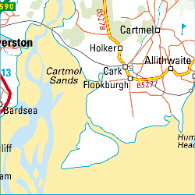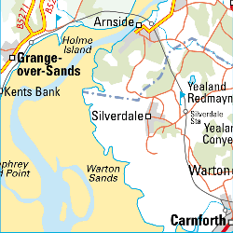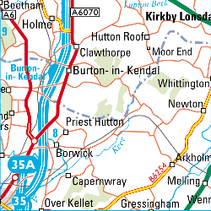

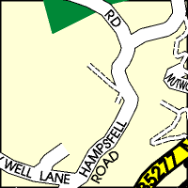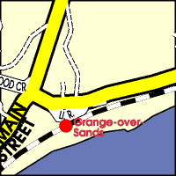

There is a leisure centre and swimming pool at the hotel
so please feel free to bring your gym clothes and swimming costume.

