Guidelines for monitoring clinical academic training and progress

A guide for trainees, supervisors and assessors

September 2011
The Conference of Postgraduate Medical Deans (COPMeD)
COPMeD is the collective body for all UK Postgraduate Deans. The Deans come together to develop UK wide implementation processes and guidelines for postgraduate medical and dental education (PGMDE). The group and individuals within the group advise departments of health and ministers on matters related to quality, feasibility and opportunities in PGMDE.

A major part of their role is quality control and quality management of postgraduate medical education working closely with those in service provider settings who deliver the education and with the General Medical Council, the accreditation bodies. Postgraduate Deaneries collect and collate information relating to the quality of postgraduate medical and dental education with trainee surveys and site visits to acute and mental health trusts, GP and dental practices.
The Academy of Medical Sciences
The Academy of Medical Sciences promotes advances in medical science and campaigns to ensure these are converted into healthcare benefits for society. Our Fellows are the UK’s leading medical scientists from hospitals and general practice, academia, industry and the public service. The Academy seeks to play a pivotal role in determining the future of medical science in the UK, and the benefits that society will enjoy in years to come. We champion the UK’s strengths in medical science, promote careers and capacity building, encourage the implementation of new ideas and solutions – often through novel partnerships – and help to remove barriers to progress.

Contents

Introduction 4
Guidelines for monitoring clinical academic training and progress 5
Annex A: Personal development plan 13
Annex B: Report on academic progress 15
Annex C: Annual Review of Competence Progression (ARCP) outcomes 16
Annex D: Example joint academic/clinical ARCP cycle 20

Introduction
The arrangements for the introduction of competence based specialty training in the UK are set out in the publication ‘A Guide to Postgraduate Specialty Training in the UK’ (The ‘Gold Guide’).

The Gold Guide identifies three key elements which will support trainees through the new postgraduate medical training structure: appraisal, assessment and annual planning. These three individual but integrated components form the basis of the Annual Review of Competence Progression (ARCP).

The process for implementing ARCP for clinical trainees is detailed in the Gold Guide (section 7). A general overview for reviewing the progression of trainees undertaking joint clinical and academic training programmes is also provided.

To aid trainees, supervisors and assessors in reviewing academic training and progress, The Academy of Medical Sciences has worked with the Postgraduate Deans, Modernising Medical Careers (MMC) and the National Institute of Health Research Trainees Coordinating Centre (NIHR TCC) to formulate supplementary guidelines.

These guidelines set out a simple, flexible framework for monitoring academic training and progress. Although the guidelines were initially developed for the Academic Clinical Fellows (ACFs) and Clinical Lecturers (CLs) introduced by the Academic Careers Sub-committee of Modernising Medical Careers (MMC) and the UK Clinical Research Collaboration (UKCRC), they are applicable to all clinical academics in training. For instance, we commend that this approach be adopted for existing CLs or trainees who are ‘Out of Programme’ in research or working for a higher degree. Differences in the structures of academic training are apparent in the four nations of the UK, & trainees in the devolved administrations are advised to note their local training arrangements.

We hope that assessors, supervisors and trainees will find these guidelines useful in preparing for and undertaking progress reviews. Feedback from all three constituencies is welcomed, the guidelines will be evolved and refined over time, to ensure they remain fit for purpose.

Guidelines for monitoring clinical academic training and progress
Aims of the guidelines
The guidelines intend to:
- Provide a simple set of criteria and a process for the assessment of academic progress.
- Characterise generic academic skills and achievements.
- Demonstrate how academic progress is to be recorded on the Report on Academic Progress form.
- Detail changes and/or additions to the review process that enable the ARCP to fulfil its function for academic trainees.

The forms developed to monitor and document academic progress are annexed to these guidelines. The forms include:
- A Personal Development Plan (PDP) designed to assist both trainees and academic educational supervisors in formulating objectives, on which progress will be judged annually (Annex A). This form and accompanying evidence can be used to assist in the completion of the Report on Academic Progress and will provide the trainee with a personal portfolio of evidence of academic skills that may be transferred between centres and appointments.
- The Report on Academic Progress form (Annex B).
- The Annual Review of Competence Progression (ARCP) Outcomes form (Annex C).

Criteria for the assessment of academic progress
Individuals undertaking academic training must have an academic educational supervisor (referred to as an ‘academic supervisor’ in this document). The academic supervisor will generally be a separate individual from the clinical educational supervisor and will usually be an established clinical academic. In the event that the academic supervisor is not an established clinical academic there should be formal mentoring or co-supervision by an established clinical academic.

The academic supervisor is responsible for drawing up an Academic Training Programme with the trainee, and a realistic/achievable timetable for delivery.

The academic supervisor is required to identify training goals relating to generic academic skills and specific academic goals for each individual as appropriate. These targets will be summarised within the Personal Development Plan (PDP) for the trainee, which should be agreed within one month of commencing work and annually thereafter (Annex A).

Generic academic competencies can be divided into three domains:
- Generic and Applied Research Skills
- Research Governance
- Communication/Education

Academic progress is to be assessed in relation to each of these domains.

At the beginning of the training period, or on entry to the training grade, the academic supervisor should agree explicitly with the trainee the criteria for assessing their progress. This should be within the framework of a general statement about the standards expected of the trainee if they are to make satisfactory progress throughout the programme.

Academic supervisors will recognize that the nature of the Personal Development Plan, and therefore the number and nature of skills to be gained over a specified 12 month period will vary both in accordance with their base line evaluation of any given candidate, and in response to local resources and priorities.

Clearly, the desired end points (in terms of achievement) for each Fellowship are relatively fixed and will dictate the academic direction each trainee will adopt. By contrast, the acquisition of generic research skills listed in the accompanying documents may occur at any time within the period of the Fellowship.

Examples of the evidence base that may be employed in supporting acquisition of skills have been provided. However, these are not prescriptive. Moreover, trainees are encouraged to employ material assembled in support of their primary research activity as evidence of generic skill.

Academic skills and outputs
Academic skills can be broadly divided into three domains and examples of each of these domains are given below. It is the responsibility of the academic supervisor to determine which of these generic academic skills are relevant to an individual trainee during the training period and to develop a training programme accordingly.

1. Generic and applied research skills
Examples include:
Identifying a research supervisor
Identifying a research topic
Defining a research question
Observational and experimental research design
Developing a research proposal
Writing a grant application
Critical appraisal of a paper or topic
Carrying out an experiment
Data interpretation and statistical analysis
Writing a research paper or thesis
Commercialisation of research outputs

2. Research governance
Examples include:
Research ethics and how it is monitored (including COREC processes)
Information storage and retrieval
Patent and Intellectual Property issues
Laboratory safety
Clinical trials / clinical trials legislation
Home Office and Animal Licences
Animal husbandry
Storage of human tissue
NHS structure and regulations
Fraud/Scientific misconduct
Knowledge of issues around misuse of research
Research and Integrity (awareness of complex dilemmas in scientific research).

3. Communication/education
Examples include:
Writing skills
Verbal presentation skills
Electronic media / audio-visual presentation skills
Poster presentations
Teaching skills/experience
Supervision skills/experience
Science and the Media
Effective networking and collaboration
Collegiality/ability to work co-operatively and creatively with colleagues
Assertiveness skills

In addition to acquiring academic skills, it is desirable that the trainee should generate research and teaching outputs. It will often be appropriate for the academic supervisor and trainee to consider in advance the outputs that can be achieved over a specific period. Significant outputs should be recorded on the Report of Academic Progress form and supporting evidence should be provided.

Examples of research and teaching outputs
- Presentation at national / international research meetings
- Submitting an application for a grant or fellowship
- Publishing a peer-reviewed article
- Delivering an educational lecture or seminar

Recording academic progress – the academic assessment
The academic supervisor should meet with the trainee at regular intervals to review progress and agree objectives for the coming period. Interim meetings should also take place half way through the year and documentation of these meetings should be submitted to the assessment panel as supporting information, having been agreed by supervisor and trainee.

An annual assessment of academic progress must be undertaken and ideally should take place at least one month before the joint academic/clinical annual review of competence progression (ARCP) panel convenes. Those present at this assessment should include the trainee and academic supervisor together with the Director of the academic programme and other members of the academic unit as appropriate. The trainee should be invited to (i) provide a written assessment of their own progress and achievements with reference to their personal development plan, (ii) describe whether their progress met their expectations, (iii) provide details of anything that may have adversely affected their progress, and (iv) discuss their personal objectives for the coming review period.
The academic supervisor is required to complete the Report on Academic Progress form (Annex B), which needs to be agreed and signed by the trainee for submission to the joint academic/clinical ARCP panel. The form must include details of academic placements, academic training modules and other relevant academic experience, together with an assessment of the academic competences achieved.

Research proposals, grant applications, and research reports and publications, may be listed as evidence of satisfactory academic progress and collated for submission to the joint ARCP panel along with any log books, case books, reports from training programme directors (TPD) and other colleagues, results of formal tests/examinations and certificates of courses attended. Trainees should find it useful to collect evidence of their academic achievements in electronic portfolios, either purpose built for specialty, or generic in nature.

The Annual Review of Competence Progression panel for joint academic/clinical trainees.

Preparation
The membership of the panel that conducts the annual review for all trainees completing the joint clinical and academic ARCP must have the right composition to enable a balanced assessment of a clinical academic trainees’ progress. Potentially, this might be achieved by a single senior academic being on the panel. However, we suggest that an optimal approach would be to include two academic representatives on the panel; one of which should be a senior academic. The Academic representatives should not be directly involved in the trainee’s academic programme, but one should ideally come from the same specialty, whilst the other should come from outside the specialty.

The review
The decision should always be made in accordance with the Gold Guide.
The trainee should not attend the joint ARCP panel unless there are concerns about either or both clinical and academic progress. Plans for academic trainees to meet with the panel should only be made if the Training Programme Director or the academic supervisor indicates that there may be insufficient academic progress or an unsatisfactory clinical outcome (Outcomes 2, 3 or 4) or both.

The assessment of the report on academic progress form
The academic supervisor should be required to submit the completed Report on Academic Progress form, along with the trainee’s supporting documentation from the academic assessment, for review by the panel.

The panel should be asked to check that the Report on Academic Progress form has been adequately completed and the academic representatives should be asked to consider the appropriateness of the Academic Training Programme that has been designed by the Academic Supervisor. The panel will then discuss what academic skills are yet to be acquired and what further skills must be obtained or improved.

Annual Review of Competence Progression (ARCP) outcomes
The panel must then consider the academic and clinical progress that has been achieved, and make a decision as to the appropriate outcome to be awarded (Outcome 1, 2, 3, 4 or 5). The outcome of this joint process should be recorded using the Annual Review of Competence Progression (ARCP) Outcomes form (Annex C). The Report on Academic Progress form should be attached to the completed ARCP Outcomes form.

If the panel recommends focussed training on the acquisition of specific clinical competencies (Outcome 2) then the timescale for this should be agreed with the trainee. If additional remedial training is required (Outcome 3) then the panel should indicate the intended outcome and proposed timescale. Although the panel is assessing both clinical and academic outcomes, if sufficient academic progress has not been achieved the trainee should not be given an outcome 2 or 3. There may however be consideration as to whether the trainee remains on the academic programme or whether they should return to the clinical training programme. A final decision regarding this can only be made in consultation with the trainee, the academic supervisor and the Director of the academic programme.
The outcome recommended by the panel will be sent to the Postgraduate Dean, trainee and their academic supervisor.

An example timeline for the annual review cycle is included at Annex D.

Additional notes for assessing academic progress
Differences in academic training structures across the UK
Although the basic principles of academic training in the UK are closely aligned, the four home countries have slightly different structures in the way that clinical and academic trainees are managed, & trainees in Scotland, Wales and Northern Ireland are advised to consult their deanery/university websites to access up to date information on academic training in their locality.

For example, information on Scottish training can found at: http://www.nes.scot.nhs.uk/media/315985/screds_guidance.pdf http://www.nes.scot.nhs.uk/media/330789/screds_annual_report_2010_11.pdf

Information on training in Wales can found at:
http://specialty.walesdeanery.org/index.php/wcat.html

Information on training in Northern Ireland can be found at:
http://www.qub.ac.uk/schools/mdbs/students/pgd/CAT/

The following notes relate to trainees within England.

Additional notes for assessing the academic progress of Academic Clinical Fellows (ACFs)
In assisting trainees to gain the appropriate research skills, it may be useful for academic supervisors to recall that:
- The ACF Programmes are primarily designed for new entrants to specialist training who have Foundation competences (including GP and Dental) and can demonstrate that they have outstanding potential for development as clinical academics in research and/or education.
- The proportion of time to be dedicated to research amounts to 25% over the 3 year period.
- Training needs to be flexible and trainee-centred, with mentoring to ensure the attainment of both academic and clinical goals.
- Each trainee who is selected for the ACF Programme will be awarded an NTN(A) at the start of the Programme.
- The academic component of the training period must include preparation of an application for a competitive peer-reviewed research training fellowship or educational training programme leading to the award of a higher degree, which may be undertaken either immediately following the ACF or at a later stage in cases where the trainee needs to continue clinical training.
- In the event that an individual is unsuccessful in obtaining a research training fellowship/educational training programme within three years, he or she will join a standard clinical training programme with consequent contractual obligations.
- The academic supervisor must therefore develop an academic training programme that focuses on the key skills that will enable the ACF to attain an Academic Training Fellowship while taking into account the limited time that the trainee has for the academic component of their post.
- It is essential that ACFs have the opportunity to develop skills that enable them, in Year 1, to define a research question, and in Year 2, to develop a research proposal. The Academic Annual Review of Competence Progress (ARCP) should record the ACF’s progress specifically in relation to these training goals.
- An application to, or the attainment of, an Academic Training Fellowship should also be recorded on the Annual Review of Competence Progression (ARCP) Outcomes form (Annex C), as evidence of progress.

Additional notes for assessing the academic progress of Clinical Lecturers (CLs) and Clinician Scientist Fellows (CSFs).
- The Clinical Lectureship Programmes aim to offer academic and clinical training to those who have completed a higher degree and have documented satisfactory progress in specialist clinical training.
- The proportion of time dedicated to research is 50% over a 4 year period.
- As with ACFs, training must be flexible and trainee-centred, with mentoring to ensure the attainment of both academic and clinical goals.
- During the four-year Clinical Lectureship phase, individuals will be working towards being Principal Investigators on grant applications and therefore, the academic supervisor may adopt a less directive role.
- An academic assessment, with completion of the Report on Academic Progress form for subsequent submission to the joint academic/clinical ARCP panel, must take place with an appropriately constituted panel for Clinical Lecturers even if they are working as independent scientists. This also applies to Clinician Scientists Fellowships.
- The academic component of the Clinical Lecturer training period will include postdoctoral research/educationalist career development with opportunities for some to develop an application for postdoctoral training support (e.g. Clinician Scientist Award or project grant).
- Academics with higher degrees will generally be expected to demonstrate their ability to supervise, to deliver teaching following sound educational principles, and develop a publication record during their appointment.
- The end of the Clinical Lectureship phase is marked by completion of clinical training and the attainment of a Certificate of Completion of Training (CCT) and also by a period of high quality, further postdoctoral training. In the event that an individual makes less than satisfactory progress in academic development, he/she will return to a standard clinical training programme with the consequent contractual obligations.
- In situations where the University already has an annual appraisal and probation record, this should be used as evidence and not duplicated for the Annual Review of Competence Progression (ARCP) Outcomes.

Annex A: Personal development plan
1. Core information

Table A
Name of trainee:
Name of Academic Educational Supervisor:
Address of Host Department:
Clinical Training Specialty: |  | Base specialty:
 |  | Sub specialty:
Address of Host Deanery:
Status of trainee (tick): |  | Academic Clinical Fellowship (ACF)
 |  | Clinical Lectureships (CL)
 |  | Other (please state)

2. Baseline Assessment of generic academic skills (Table B, columns 1 and 2)

Date of commencement of training year:
Year of programme (ACF, 1-3; CL 1-4):
Date of Baseline assessment

Table B
 | Academic skill to be achieved during period of contract (12 months) | Means by which academic skill will be achieved (e.g. by taught course, through satisfactory completion of specific task etc). Include specific agencies, venues and dates where applicable. | Nature of material appended indicating satisfactory acquisition of skill, with signature of the Academic Educational Supervisor | Reason as to why research skill was not achieved. Proposed action to ensure skill acquisition
Skill 1

Skill 2

Skill 3

Skill 4

3. Annual assessment of generic academic achievements (Table B, columns 3 and 4)

Date of commencement of training year:
Year of programme (ACF, 1-3; CL 1-4):
Date of assessment:

4. Annual assessment: summary of generic academic achievements
Academic Educational Supervisor (signature) |  | Date
Academic Trainee (signature) |  | Date

Annex B: Report on academic progress
(This form supports the annual review outcome and should form part of the trainee’s permanent record)
Deanery: _________________________________Training Programme Reference No.______________
Name: ________________________ Specialty _______________ NTN / NTN (A):_________________
Members of the Panel: 1_____________________________2__________________________
3_____________________________4__________________________
5_____________________________6__________________________

Date of Report _______________________________
Period covered: From __________________________ to _____________________________
Year / phase of training programme assessed (circle): 1, 2, 3, 4 or other (state) ____________
Academic competences gained during period of review (full details of programme should be attached):

Experience gained during the period:
Placement / Post/ Experience | Dates: from | to: | In / out of Prog | PT / FTPT as %FT
1.
2.
3.
4.
5.
Significant academic outputs during the period:
1.
2.
3.
Documentation taken into account and known to the trainee:
1.
2.
3.
4.

Recommendations:
Trainee (signature) Date of next review (unless not relevant)

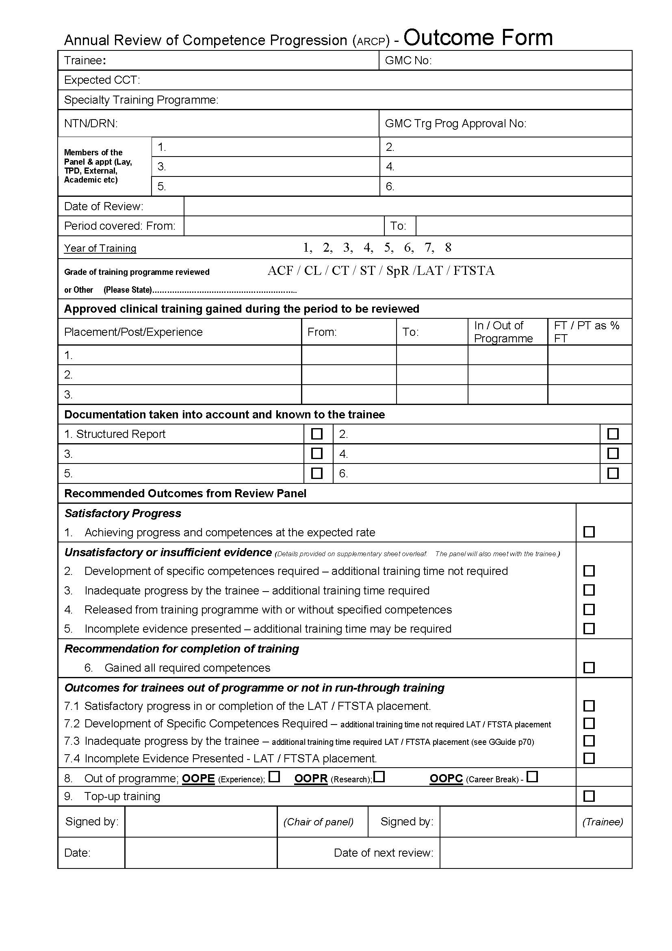
Annex C: Annual Review of Competence Progression (ARCP) outcomes

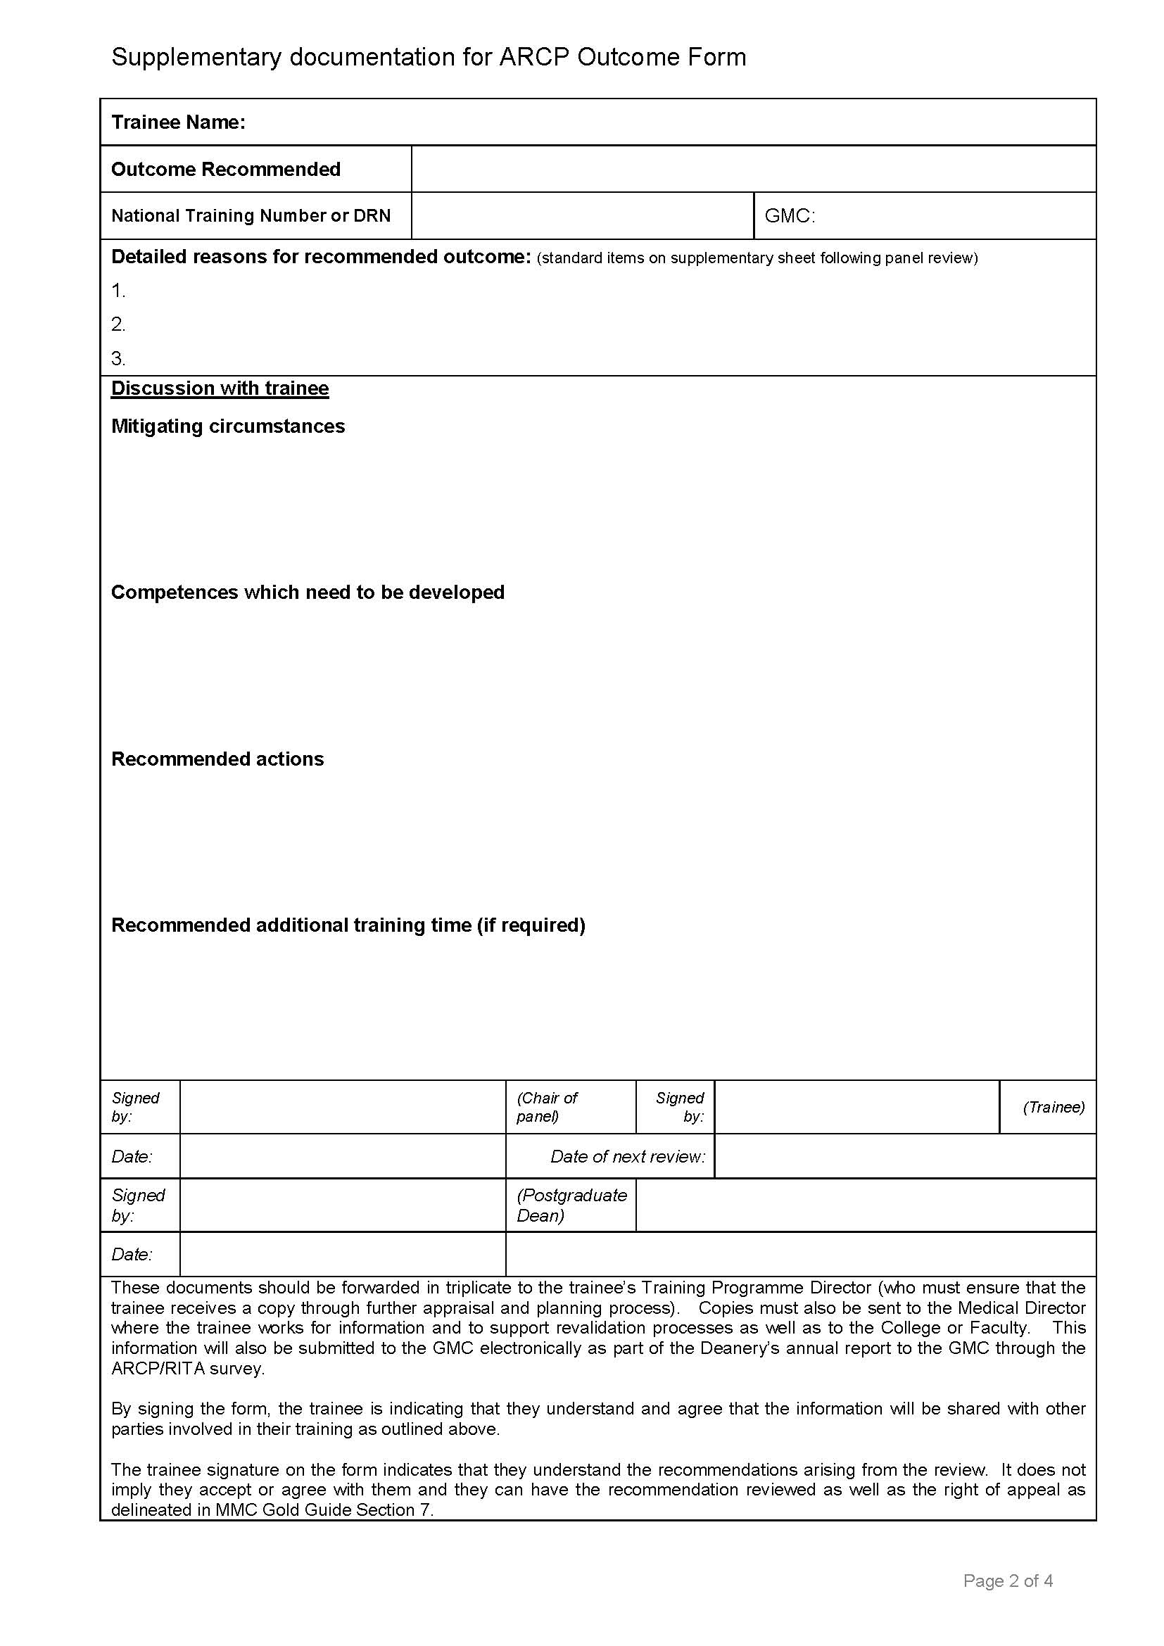
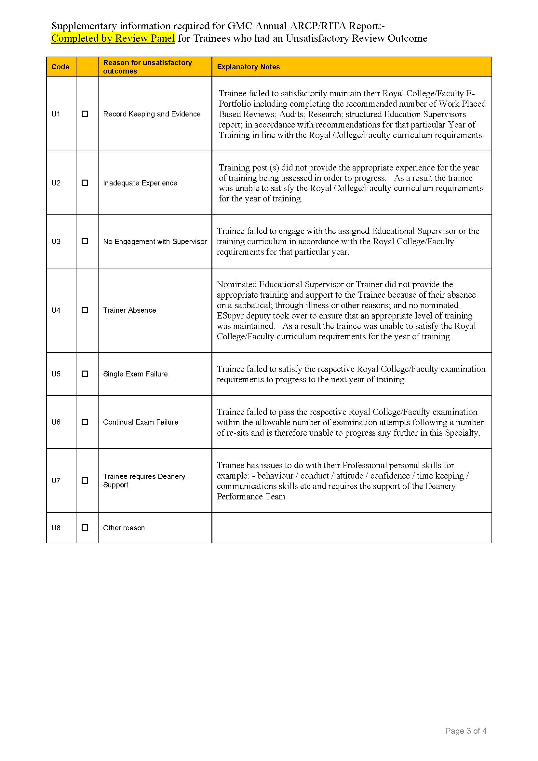
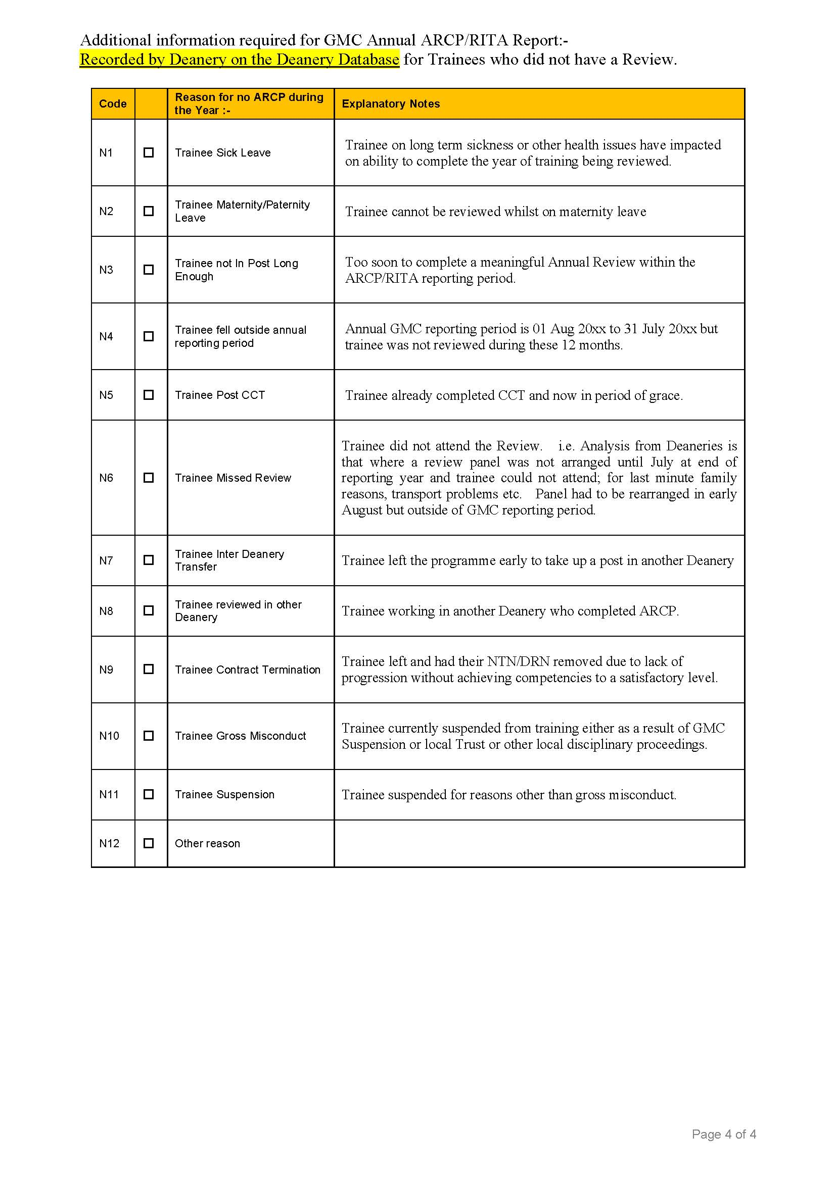

Annex D: Example joint academic/clinical ARCP cycle
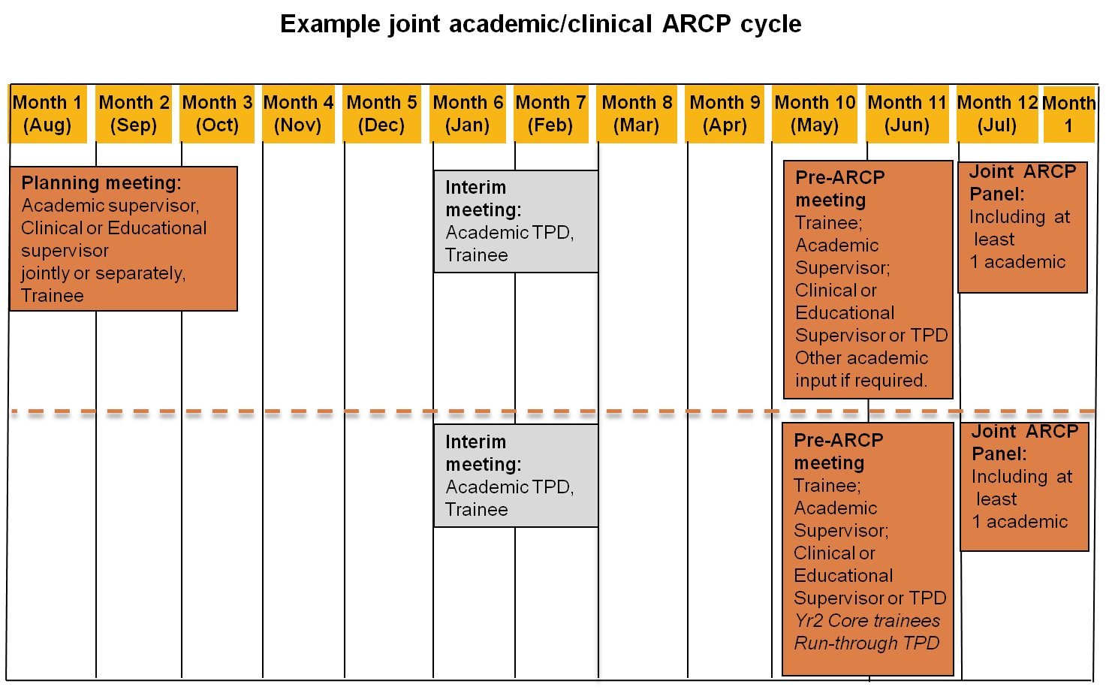

Academy of Medical Sciences
41 Portland Place
London W1B 1QH
+44(0)20 3176 2156
info@acmedsci.ac.uk
www.acmedsci.ac.uk

Registered Charity No. 1070618
Registered Company No. 3520281

A Guide to Postgraduate Training in the UK, ‘The Gold Guide’ v4 2010 http://www.mmc.nhs.uk/pdf/Gold%20Guide%202010%20Fourth%20Edition%20v08.pdf
Report of the Academic Careers Sub-Committee of Modernising Medical Careers and the UK Clinical Research Collaboration (2005).Medically – and dentally-qualified academic staff: Recommendations for training the researchers and educators of the future. http://www.ukcrc.org/PDF/Medically_and_Dentally-qualified_Academic_Staff_Report.pdf
Since the assessment process jointly assesses academic and clinical progress, the trainee must also submit evidence of clinical achievement as per the process defined in the ‘Gold Guide’. The clinical educational supervisor’s report must indicate the ‘pro-rata’ rate of acquisition of clinical competences has been satisfactory, given the time commitment available for clinical training.

