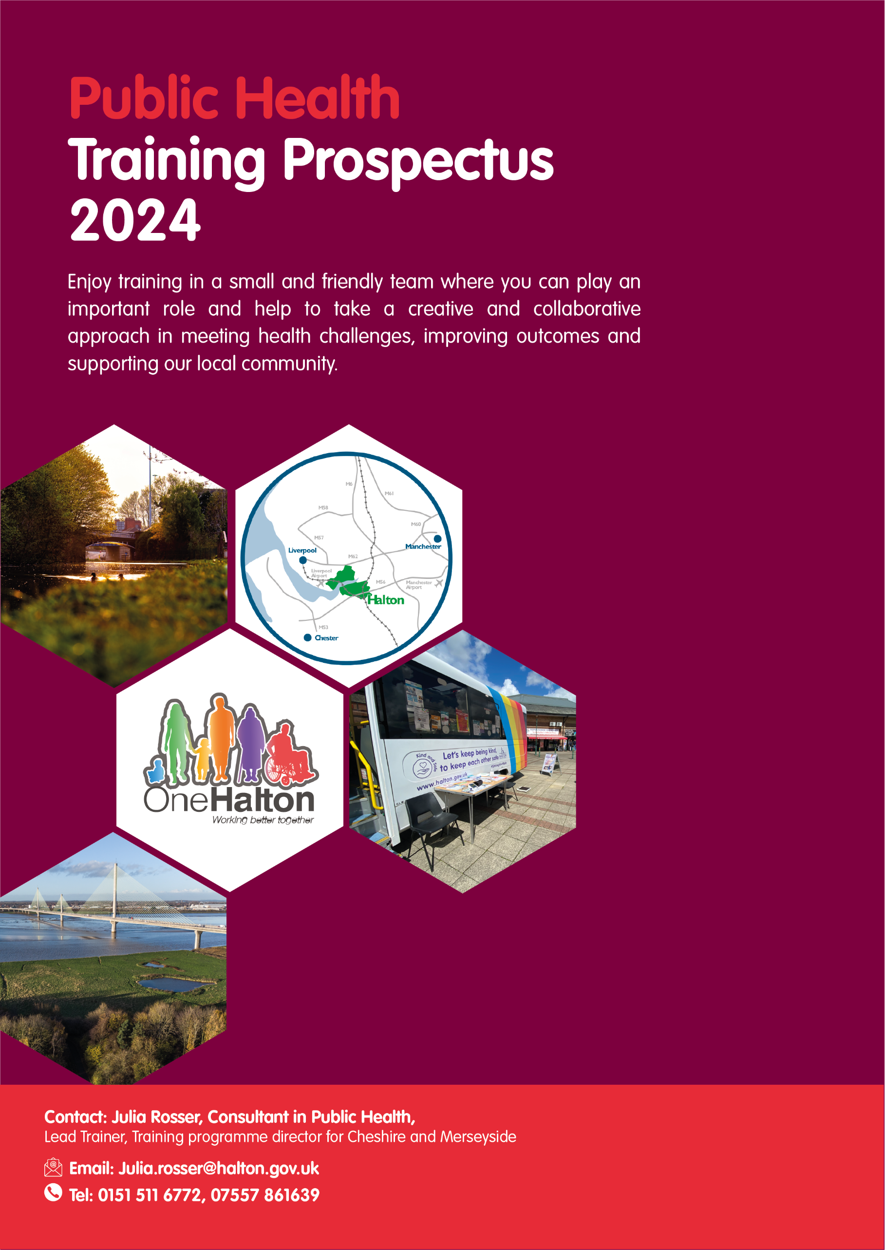

**Why choose Halton?**

Halton Borough Council is a unitary authority located between Cheshire and Merseyside, covering the two major towns of Runcorn and Widnes which sit either side of the River Mersey. The borough has a diverse economy with a focus on logistics, science and manufacturing. There is a rich industrial heritage which has shaped the towns and countryside, with local canals and rivers playing a major role. Our waterways are important to the area and Runcorn continues to be a thriving port.

Compared to many other local authorities, our population of around 128,000 people is relatively small. This gives the Council and the Public Health Team opportunities to concentrate public health resources and to target diverse groups and communities.

Our borough also has some challenges including addressing national and regional trends that show worsening of some key health issues such as mental health, cardiovascular disease and accessing screening and preventative health opportunities.

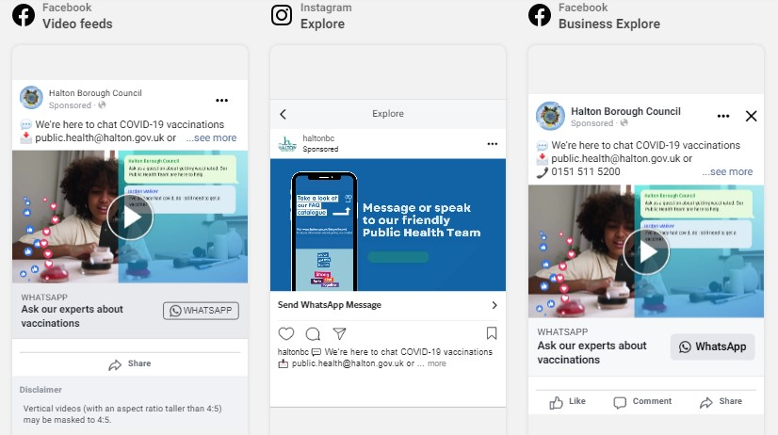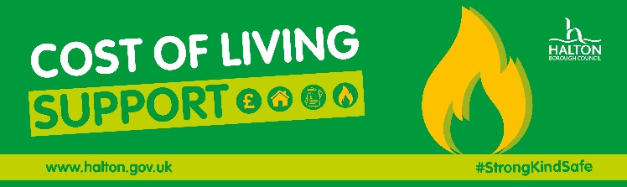The effects of the rising cost of living and other wider social determinants all play a part in real difficulties for many in our community.

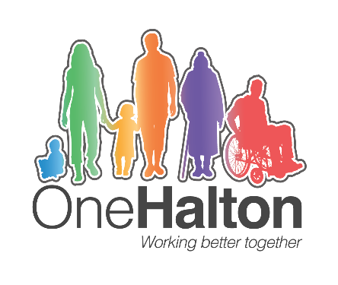 We have a system-wide approach to health, wellbeing, and care under the ‘One Halton’ banner. Bringing together strategic leaders from all partner agencies within Halton and provides significant opportunities to experience and demonstrate systems leadership.

Our strong connections to our neighbouring authorities in the Liverpool City Region and Cheshire enable funding and a co-ordinated approach in meeting many of these challenges.

The Public Health Team has a good balance of very experienced and knowledgeable staff together with people at various different stages of their careers. This brings us a wealth of skills and ideas and we regularly collaborate on many projects both within the team and with colleagues across the Council and local partners. Our team is proud to punch above our weight and to take a creative and collaborative approach to ensuring everyone in Halton has the best possible health.

We are looking for people to join our team who want to make a difference everyday, using their unique set of personal and professional skills to support our community and each other.

**Halton Public Health Team – who are we?**

|  |  |
| --- | --- |
| **Dr Ifeoma Onyia**  Dr Ifeoma Onyia, Director of Public Health**Director of Public Health** | Ifeoma joined Halton in 2013 and became Director of Public Health in 2021. Reporting directly to Stephen Young, Chief Executive, Ifeoma oversees health improvement, health protection, healthcare public health, environmental health and trading standards.  The Director of Public Health also supports the chair of the Health and Wellbeing Board and leads the development of the health and wellbeing and ICS strategies.  “I trained in the Northwest and interestingly started my very first public health placement in Halton. It’s a very lively place to work with good intelligence support from the team and very close working links with local NHS organisations, making it easy to start conversations, exchange ideas and influence planning. There are opportunities to work directly with primary care, support NHS work, conduct needs assessments and other related work. Thank you for your interest in Halton and get in touch if you would like to know more.”  To get to know Ifeoma a bit better please link [here](https://www.champspublichealth.com/local-spotlight-haltons-dr-ifeoma-onyia-on-local-public-health-her-new-role-as-director-the-challenges-the-borough-faces-and-more/) |
| **Julia Rosser**  **Deputy Director of Public Health**  Consultant in Public Health  Lead Trainer  Julia Rosser, Consultant in Public Health | Julia is the training lead in Halton and leads on maternal and child health. She is also the Training Programme Director for Cheshire and Merseyside.  ‘In Halton we take training very seriously and value the contribution that registrars bring to the team. We aim to fully integrate registrars into the team and provide a full induction and ongoing support. I, like the other consultants, trained in Halton. I completed my final two years here and had an acting consultant post, with the lead for maternal and child health in my final months on the scheme. I was very grateful for the high level of responsibility and opportunities offered to me here during my training.  I have always found Halton to be a great place to work. The Public Health team are supportive and friendly, and the area is small enough that you get to know people easily. The health profile of Halton means there are plenty of challenges and opportunities to work across the spectrum of public health and develop your areas of interest. The local organisations strive to work collaboratively and in an integrated way, indeed the quality of the partnership working in Halton has been commended in inspections.’ |
| **Fiona Watson**  Consultant in Public Health   | Fiona is the lead consultant on Healthcare Public Health, supports the Data and Intelligence team and has a focus on working age adults’ health improvement.  She has a dental background so also leads on oral health and intends to resume being an ES in Public Health in the spring.  ‘I recently joined the team in 2023 and am enjoying the return to Public Health in Local Authority following several years working in PHE and then OHID. Halton benefits from its unique geography and relatively small population which support you to make a meaningful contribution to Public Health.  The local ICB place-based staff are co-located with us at Runcorn Town Hall helping integration and work together in a rapidly changing environment.  This is a great year to join us as there is some exciting partnership work being developed to address the ever increasingly complex challenges across the system.’ |
| **Beth Milton**  Consultant in Public Health   | Beth is a Consultant in Public Health, and leads on health protection, drugs and alcohol, sexual health, vulnerable groups, and the wider determinants of health. She is an Educational Supervisor.  ‘I carried out my specialty training in Public Health in Cheshire and Merseyside. I am a non-medic, with a background in academic Public Health which focussed on social inequalities in health.  I really enjoy working with Specialty Registrars, and with the FY2 doctors who come to Halton on rotation. Recent projects which SpRs and FY2s have worked on in relation to my portfolio include a Health Needs Assessment for local Gypsy, Roma and Traveller communities, insight work with young women to understand their experiences of accessing LARC and sexual health testing, leading engagement with local asylum seekers to promote latent TB screening, developing dual diagnosis pathways for people with co-occurring drug or alcohol use and poor mental health, and strategy development for the Halton Combatting Drugs Partnership.’ |

# How we support your training.

We can host up to two registrars as well as foundation doctors on their four-month public health placement. We are all based in the same office, but are operating a hybrid approach, with a mix of home working and being in the office at least two days a week.

Registrars are fully integrated into the Halton public health team and are invited to participate in team meetings, senior management meetings, journal clubs and organisational workshops, with opportunities tailored to their training requirements and stage of training. Registrars are also encouraged to participate in internal and external sessions for preparation for their faculty exams. Senior registrars gain leadership experience, working closely with the DPH in Halton and regionally, and through developing a portfolio of work. They are also encouraged to support more junior registrars, and provide supervision, training and management of foundation doctors.

All registrars will be assigned a trainer based on their interests and training requirements. There are regular structured meetings with the trainer. The registrar will work closely with and have access to all the consultants and the director of public health on a day-to-day basis.

# Particular interests and training opportunities

Within this training location there is a particular interest in the wider determinants of health and in using evidence-based methodologies to prevent ill-health. There are good opportunities to gain an understanding of partnership working, community engagement and involvement, and commissioning for health improvement. More senior registrars are encouraged to develop their leadership experience and to start to lead on agreed areas of work.

Halton Public Health team are uniquely placed to provide the very broadest range of public health experiences, being the only public health team within the Northwest (possibly nationally) to be fully integrated with the Environmental Health team and Public Protection services.

The close nature of partner agencies and development of novel system wide approached provides invaluable opportunities to gain experience of high-level system leadership approaches in action and develop experience of working within a culture of innovation from the highest level.

**What’s in it for you?**

* All registrars are provided with a laptop and phone and any other IT/working equipment as needed.
* Registrars are a member of the Public Health management team and have access to admin and project support.
* The team are based at Runcorn Town Hall which is situated in a beautiful park area and offers free parking for staff. The building is fully accessible.
* Flexible and remote working is available
* You’ll have access to a wide range of employee initiatives geared towards looking after, managing and improving mental and physical health.
* Wide range of training and learning opportunities, both corporately and within the Public Health Team.
* Halton has excellent travel links across Cheshire and Merseyside, connecting you to great work, social and leisure opportunities including a broad selection of shops, restaurants, cinemas, leisure facilities, libraries, parks and museums.

**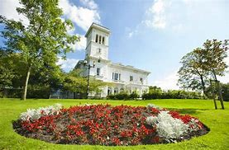

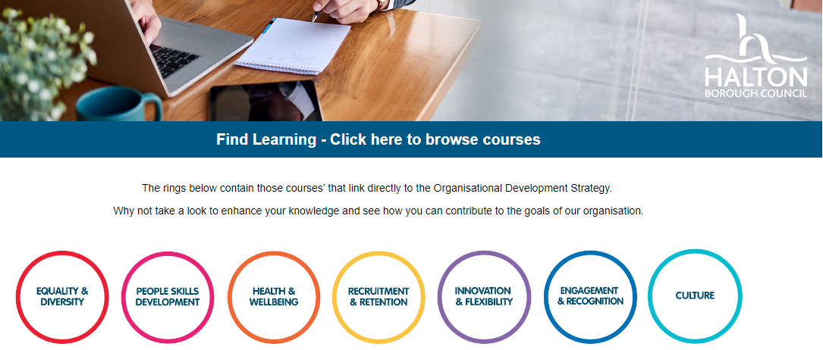

**Halton is a great place to work but don’t take our word for it!**

This is what our recent registrars have said…

“The Halton team have been incredibly friendly and made me feel welcome as a new trainee. Adjusting to new ways of working or placements can be daunting, but I have felt supported by various members within the team.

There are great opportunities to get involved in a wide array of projects. I am currently developing a health needs assessment for the Gypsy, Roma and Traveller community and have been involved with community engagement sessions, Environmental Health assessments and visiting with port health officers. Most of my time is spent completing the MPH and I have felt valued within the team, despite only being available one day a week. Halton regularly hosts FY2 doctors and registrars are given opportunities to lead teaching sessions and get involved with journal clubs – something that has really helped me consolidate my critical appraisal skills, I would definitely recommend Halton!”

**Dr Chloe Taylor, ST1, 2023-Present**

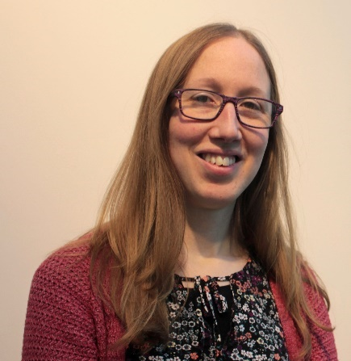“The public health team has wide-ranging expertise and a broad portfolio. I have found that there is opportunity to get involved across different areas, develop ideas and lead on new pieces of work.

I have been able to do a variety of pieces of work, including: supporting with schools COVID-19 advice; evaluating a programme to provide free activities and nutritious meals for children during school holidays; reviewing local health needs and approaches around affordable warmth and presenting findings to the One Halton place-based Board; coordinating journal club sessions and supporting F2 placement doctors; and engaging with stakeholders to produce the updated drugs strategy. I would highly recommend Halton as a placement location.”

**Dr Anne Doble, ST2, 2022-23**

I transferred into Halton in 2022 and was welcomed with open arms. I’ve been able to benefit from the expertise of the team in many ways and have been fully supported during difficult times by supervisors and DPH alike.

Once settled, I’ve been able to benefit from opportunities to be involved in more or less anything I’ve needed. This has ranged from line managing our FY2 doctors and delivering teaching sessions; writing our infant feeding strategy and our sexual health needs assessment and spending a day shadowing the Port Health team. I was supported to do all of this while also going through the trials of the FPH exams.

The team has a great blend of caring and compassion allied with a drive to achieve good outcomes for local residents. The Public Health function in Halton is different from most other areas as its Health Improvement function is in-house. This presents a unique opportunity within the region to be closer to the coalface if that‘s your thing.

Given the local population face some of the most difficult challenges in the region, it’s not only a great place to train and gain experience, but also one where you could thrive longer term.”

**Adam Major, ST4 2022-Present**

# Background pattern Description automatically generatedOur networks and links

# Helping to connect and support your training journey

# Academic links

There are good links with local Universities, including Liverpool University, Liverpool John Moores University, Chester and Salford University, and opportunities to collaborate on pieces of work. Ifeoma’s NIHR role developing research opportunities also provides additional exposure to regional research opportunities.

# Clinical governance/CPD

The public health team provide opportunities for continuous professional development and learning. There are regular team meetings where time is set aside for clinical governance and learning. Senior registrars are given the opportunity to organise learning events for the team and are encouraged to support and engage in the journal club.

# Foundation doctors teaching and supervision

Registrars in Halton are able to contribute to the delivery of Public Heath teachings for F1 doctors, one-to-one learning sessions for F2 doctors as well as acting in a supervisory role.

Halton Public Health host Foundation 2 doctors on their 4-month rotation. This provides opportunities for Public Health registrars to deliver one-to-one learning sessions in various aspects of public health. The F2 doctors undertake a wide variety of projects and there is an opportunity for senior registrars to supervise some of the projects.

For example, one of the F2 doctors produced a Needs Assessment on Unaccompanied Syrian Children (UASC) under the supervision of a senior registrar. This work won the FPH Sam Ramaiah Award which rewards projects seeking to improve the health of black and minority ethnic communities or reduce health inequalities in the United Kingdom.

**Examples of Registrars’ work**

* Support the production of the GP practice health profiles
* **Background pattern

  Description automatically generated**Evidence reviews of arts and health
* Evaluation of long-term conditions pilot
* Support the production of the public health annual report
* Project managed the setting up of a breastfeeding incentive programme
* Evaluation of Healthy Start Vitamins Pilot
* Researched and compiled the Suicide Audit
* Survey into public perceptions and public engagement on air quality
* Lead for reducing alcohol harm
* Lead for child and maternal public health
* Lead on the delivery of the community conversation around alcohol (Alcohol inquiry)
* Fuel poverty Needs Assessment
* Development of Affordable Warmth strategy
* Lead for Affordable Warmth strategy
* Review of sexual health service
* Review of non-clinical HIV support service
* Commissioning substance misuse services
* Working with trading standards to support people who are victims of scams.
* Work with the CCG to pilot having a paediatrician working within the community
* Health Needs assessment into young offenders’ health
* ****Cross health and care economy system wide strategic development