TRAINING PROSPECTUS WARRINGTON AND HALTON TEACHING HOSPITALS NHS FOUNDATION TRUST

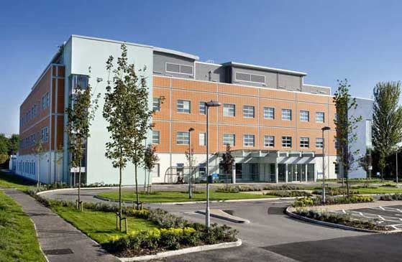
Captain Sir Tom Moore Building, Halton Hospital

- INTRODUCTION

Warrington and Halton Teaching Hospitals NHS Foundation Trust takes its public health responsibilities seriously. It’s 2023-2025 strategy includes a strong focus on reducing inequalities.

“We recognise and act on our role as an advocate for the health and wellbeing of our local communities. We know unfair and avoidable differences in health can be caused as a result of a society, the environment we love in and the opportunities we have”.

The Trust’s overall CQC rating is Good. Quality improvement drives the ethos of the hospital, and it has an active Quality Academy with a key component of tackling health inequalities. The hospital has a clinical research unit, which provides a strong base for working with academic partners in the region.

It serves a population of around 500,000 people.

This is a good placement for refining and embedding competencies in relation to healthcare public health and for understanding the wider public health system. NHS Trusts seems to be increasing the numbers of public health qualified posts and this is a friendly and welcoming hospital trust where people will take time to get to know you. This makes for a very inclusive workforce and an ideal place for a Public Health Registrar who is keen on gaining competencies in an acute NHS setting.

There are opportunities for registrars to support the Trust’s agenda and to work on a variety of projects, such as:

- Supporting the Trust’s anchor institution agenda, working in partnership with the two local authorities, community and voluntary sector to use the leverage of the Trust to tackle inequalities.
- Lead the delivery of prevention pledges workstreams agreed by WHHT.
- Supporting the development and delivery of WHHT’s plan for population health and reducing health inequalities.
- Using population health management methods to support system wide work to improve population health and to support the development of virtual wards as an alternative to hospital admission.
- Creating dashboards to support services to review attendance by ethnicity, gender, age and deprivation.
- Quality improvement projects.
- Equity audits e.g. targeted lung health check programme, emergency care.
- Developing and evaluating strategies e.g. alcohol and healthy weight.

- THE TEAM

Thara Raj is the Training location lead and Education Supervisor. She is Director of Population Health and Inequalities at Warrington and Halton Teaching Hospitals NHS Foundation Trust (WHHT). Thara’s role is to support teams to improve the physical and mental health outcomes of patients, promote wellbeing and reduce health inequalities across the population and communities that the hospital serves. Prior to coming to the hospital Thara was Director of Public Health for Warrington Borough Council and has worked in public health roles for over 30 years at a local, regional and national level.

The Director of Population Health & Inequalities reports to the Deputy Chief Executive and has an overarching responsibility to work with each of the Executive Directors to embed a population health and inequalities approach across the Trust.

We have a number of potential Activity Supervisors at the Hospital who are trained Education Supervisors in their clinical speciality and who are interested in public health and supporting the development of public health registrars. These Activity Supervisors include the Foundation Training Directors who are keen advocates of public health and who have supported public health placements for the Foundation Training Programme.

- LOCATION

The Trust has several sites in Warrington and Halton and runs a number of hubs in community settings and offers flexible and hybrid working. Registrars are provided with a laptop, smart phone and secure remote access so working from home is possible and encouraged.

- CONTACT

To find out more please contact Thara.RajNHS@nhs.net by email or by phone on 07748 180679.

