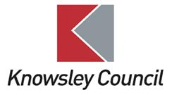
KNOWSLEY PUBLIC HEALTH DEPARTMENT

PUBLIC HEALTH SPECIALTY TRAINEE TRAINING PROSPECTUS

January 2024

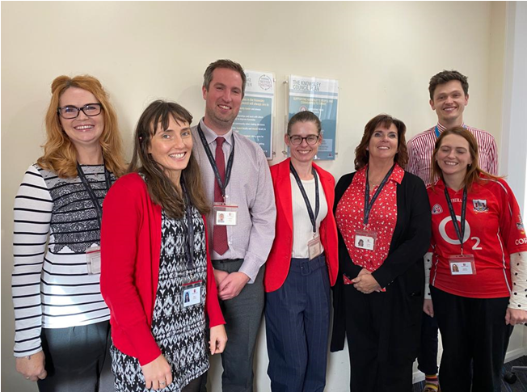

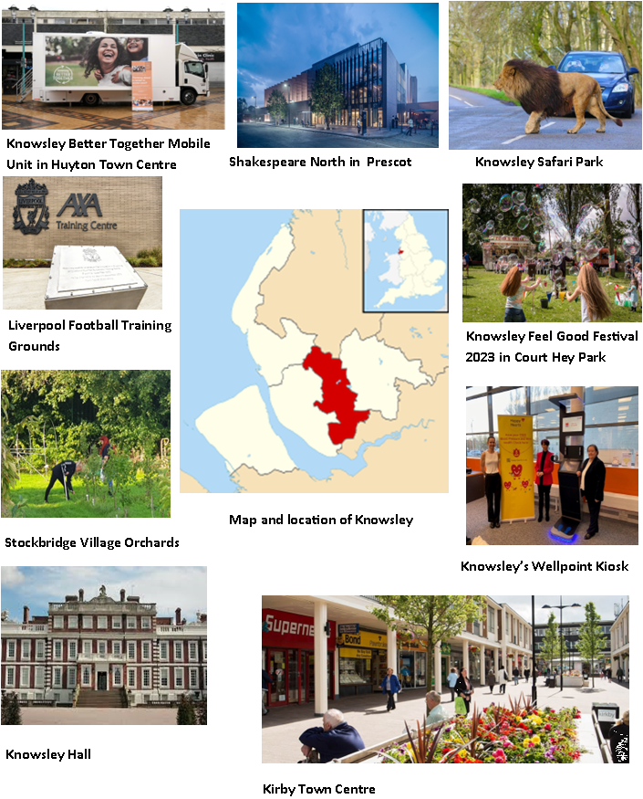

Reasons to Choose Knowsley:
· Specialty Registrars based at Knowsley are given the support and opportunity to get involved in all aspects of public health work, looking at the wider determinants to improve health and wellbeing, influence policy and address inequalities within the borough.
· Specialty Registrars are fully integrated into the Public Health Team, and are well supported during their training to ensure competencies are achieved. Work plans are aligned carefully to learning needs and the Accredited Trainer and Senior Team are experienced at supervising projects and programmes.
· Exposure to projects in all aspects of healthcare public health, health protection, intelligence, commissioning and health improvement and wider determinants can be catered for in Knowsley.
· The Public Health Team has a strong and well-established relationship with the wider Council and other local partners, providing valuable insights into working in a political environment, as well as working closely with colleagues including NHS, social care, housing and community sector organisations.
· As a relatively small Public Health team and Local Authority, a placement at Knowsley creates a unique opportunity to be a key member of the team, to have exposure to different aspects of public health and to contribute and engage with council and partnership meetings. Having a broad exposure creates an opportunity to explore interests, respond to challenges and develop skills for a career in public health.

1. INTRODUCTION

Knowsley is a relatively small Local Authority in North-West England, covering an area of 33 square miles. It has a resident population of approximately 154,500 and is situated just to the east of Liverpool and is within easy reach of the rest of Merseyside, Cheshire and Manchester. The population does not have high levels of diversity and black and minority ethnic numbers are low.

Improving the health and wellbeing of Knowsley residents and individuals who work in the borough is vital to future economic growth and improved life chances and outcomes. While most people live happy and healthy lives throughout the Borough, there is a higher proportion of adults that live longer in poor health and with chronic illness and die prematurely. As a borough we have higher than national averages for smoking, drug misuse, inactivity and overweight / obesity. The Knowsley population experiences higher rates of cancers, respiratory disease, heart disease, liver disease and strokes than in other areas.

Knowsley had made improvements to health over the last 10 years or so, but health disparities and inequalities have been exacerbated during and because of the COVID-19 pandemic and the increases in the cost of living.

Our latest JSNA can be found here.

Knowsley was disproportionately affected by the Covid-19 pandemic, with the second highest case rate in England. As the second most deprived local authority in England, our population is particularly affected by the current cost-of-living crisis.

Knowsley faces a number of challenges to improve the health and wellbeing of residents; and has some of the poorest health outcomes in the North-West.

The 2019 Index of Multiple Deprivation ranked Knowsley as the second most deprived local authority in England (of 317). Residents’ health is also impacted negatively by the social determinants of health such as poor housing, education and unemployment.

Public Health within the Local Authority are well placed to help improve lives by influencing the wider determinants of health and addressing health inequalities.

Knowsley 2030

In response to these challenges, the Knowsley Better Together partnership developed the Knowsley 2030 Strategy, which is a long-term plan to address inequalities and support residents and communities to thrive.

Health and wellbeing is a corporate priority, with the ambition that Knowsley is a place where people are active and healthy and have access to the support they need to thrive. The Council and the Public Health Team works well with a range of other departments and partners on improving outcomes. Being a relatively small council creates strong working relationships to facilitate this. Knowsley also has a history of strong public and partnership collaboration. Through enabling community and voluntary networks, public health issues have a very high profile. Being a smaller borough allows us to focus on relationships with our partners, including our NHS partners. We are co-terminus with Knowsley NHS place.

Our 2030 Evidence Base can be found here and the 2030 Strategy here.

The placement will provide opportunities for Specialty Registrars to develop a strategic approach to improving health and wellbeing, and to influence policy around the wider determinants of health and address inequalities. The placement also offers a valuable insight into working in a political environment, including regular opportunities to present papers to the Cabinet Member for Health.

There is close working with the wider Liverpool City Region, along with very close relationships with the Champs Network.

2. STRUCTURE OF THE TRAINING LOCATION

The Knowsley Public Health Team comprises of the Director of Public Health, 2 Public Health Consultants, 2 Programme Managers and 2 Programme Officers. The team also includes a Public Health and Early Years Integration Co-ordinator to strengthen links between Public Health and the 0-25 service. The team is always exploring ways to encourage innovative ways of working across departments. The Public Health team work closely with Intelligence Analysts who are part of the Council’s Policy and Performance team and Commissioning colleagues who are part of the Council’s wider Whole Life Commissioning team. The team sits within a Health and Social Care Directorate. Specialty Registrars are physically located with the friendly Public Health team.

Knowsley has 2 (3 from August 2024) accredited trainers, Dr Sarah McNulty, Director of Public Health, who will supervise and guide senior trainees, Ross Keat, Locum Consultant in Public Health and Richard Holford who is in the process of completing the Educational Supervisors training course. Two of the three supervisors in Knowsley have been through the specialty training programme and so have first-hand experience to help guide and support trainees to get the best out of the training scheme, navigate competency requirements and examinations, and be on hand to support any challenges. All Registrars are treated as members of the Public Health Team and will be allocated their own laptop with access to flexible and remote working around business needs.

All Specialty Registrars are supervised by the Accredited Trainer and supported by key members of the Public Health Leadership Team to complete programmes of work and gain competencies.

Specialty Registrars are offered support throughout their placements with dedicated one-to-one meetings with their Supervisor. They are highly respected members of the team and are encouraged to participate in monthly team meetings, Public Health Strategy Group meetings and relevant Council and Partnership meetings. Senior Specialty Registrars can also attend Leadership meetings with the wider portfolio of the DPH. Specialty Registrars are encouraged to participate fully in the development offered via the School of Public Health.

2.1 Location & hybrid working

The Knowsley Public Health Team base is the Council Office, Municipal Building, Archway Road in Huyton. This is close to Huyton Town Centre. There is free long stay parking near the office. Secure cycle stores outside the office building are also available with changing facilities. The railway station is a 5-minute walk away and there are good road and public transport links. The council has flexible hybrid working, with the team usually coming together for shared office days – currently Tuesdays and every other Thursday.

3. INTERNAL AND EXTERNAL LINKS

The Director of Public Health sits within the directorate for Health and Social Care, with an executive director lead and lead portfolio holder. The Public Health Intelligence Team are co-located with Policy and Partnerships (the Corporate Intelligence Team), and therefore Public Health actively contributes to the development of corporate strategy. There are also strong links to NHS Cheshire and Merseyside Knowsley place team who are also based in Huyton.
Knowsley is proactive in its collaboration across the City Region and the Cheshire and Merseyside Public Health Network. This provides many opportunities for Specialty Registrars to develop working across a larger footprint.

4. ACADEMIC LINKS

There are good links with local Universities, including the University of Liverpool and Liverpool John Moores University.

Knowsley Council was a partner on the Northwest Coast – National Institute for Health Research Collaboration for Leadership in Applied Health Research and Care programme (CLAHRC); and continues to be a member of its replacement – Applied Research Collaboration (ARC). This collaboration includes Lancaster University, University of Central Lancaster, University of Liverpool, Local Authorities and Health organisations to co-produce and conduct high-quality, applied research designed to decrease health inequalities and improve the health of the population of the Northwest Coast. The applied health research is under several themes, which may be of interest to the applicant. Richard Holford, Consultant in Public Health, is our Research lead and helps guide and support registrars interested in research opportunities. Additionally, there is an established Cheshire and Merseyside Public Health Research Hub which provides further opportunities for research involvement.

5. PARTICULAR INTERESTS AND TRAINING OPPORTUNITIES

Within this training location there is a particular interest in the wider determinants of health and in using evidence-based methodologies to prevent ill-health. There are good opportunities to gain an understanding of partnership working, community engagement and involvement, and commissioning for health improvement. Senior Specialty Registrars can take on leadership roles in particular areas.

6. ORGANISATION OF TRAINING

Specialty Registrars’ programmes of work are aligned carefully to learning needs, with specific exposure to all aspects of population health. There are regular structured meetings between the Specialty Registrar and their Educational Supervisor. Regular stock-takes of progress against the public health curriculum are undertaken, along with support to achieve the Diplomate and Final Membership Exams. Specialty Registrars are encouraged to play an active part in the Northwest Public Health Registrars’ Network.

7. EXAMPLES OF RECENT TRAINEES’ PROJECTS

• Leadership of smoking and vaping strategy and action plan
• Evidence and pathway review of the Council’s referrals to residential rehab services
• Recommission of the Infection Prevention Control Service
• Oral Health Joint Strategic Needs Assessment
• Commissioning an Oral Health intervention, including supervised toothbrushing

8. WHAT REGISTRARS SAY ABOUT KNOWSLEY

“When I joined the Public Health team at Knowsley Council, I was met with a warm welcome and instantly felt like part of the team. Prior to joining, I discussed my outstanding Learning Outcomes with my supervisor, and they ensured my pieces of work aligned exactly. As an ST3/ST4, I feel I have been given the opportunity to lead on project areas, but still had the support from my supervisors and wider PH team who have always been happy to share their wealth of knowledge and experience when I’ve needed it. My supervisors have been a great support throughout, helping with preparation and conducting practice scenarios for my MFPH exam and with regular meetings to discuss project areas. I would recommend Knowsley to peers as great training location, with its friendly and welcoming atmosphere and a wide range of interesting challenges and opportunities.” (ST3/ST4 2022-2024)

“Knowsley Council is a brilliant place to work as an SpR. The team are not only welcoming, helpful, and extremely knowledgeable but they are also great fun to be around. Alongside this great atmosphere, Knowsley offers rare opportunities to work in the forefront of innovative projects due to the teams creative problem-solving nature. I joined the team as an ST1 and was given a substantial amount of guidance and direction from all team members. My supervisors have also been really supportive not just with work in relation to Knowsley but also with the MPH and DFPH exam.” (ST1/ST2 2021-2024)

“The public health team in Knowsley are great fun and very welcoming of Registrars. I joined them in my final year of training and am currently completing a review of their specialist obesity service and development of the service specification. It has been the perfect piece of work to sign off my remaining learning outcomes, and the team have been incredibly supportive throughout”.

“Knowsley Council is a friendly and vibrant training location for SpRs. I joined the team on commencement of St4. I was tasked with delivering a wider variety of work, all great for maintaining my technical skills, gaining strategic experiences and achieving ticking off many phase three learning outcomes. This included developing the unintentional injuries strategy/ portfolio and supporting various activities related to healthcare services, such as a review of lung cancer screening. I would recommend Knowsley to peers as an excellent training opportunity. My work at Knowsley has enhanced my training and portfolio, which has led me to closer working at the University of Liverpool and more recently supporting my application as a Research Fellow.”

9. WANT TO KNOW MORE?

For further details or to arrange a visit, please contact

Dr Sarah McNulty
Director of Public Health
Tel No: 0151 443 4910
sarah.mcnulty@knowsley.gov.uk

Ross Keat
Locum Consultant in Public Health
Tel: 07384900830
Ross.keat@knowsley.gov.uk

February 2024

