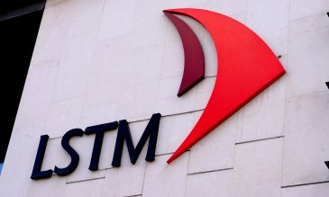
Liverpool School of Tropical Medicine (LSTM)

Liverpool School of Tropical Medicine (LSTM), founded in 1898, was the first institution in the world dedicated to research and teaching in the field of tropical medicine.
As a registered charity, we work across the world, often in very difficult circumstances, to fulfil our mission of reducing the burden of sickness and mortality in disease endemic countries. We do that through the delivery of effective interventions which improve human health and are relevant to the poorest communities.
Our work in combating diseases such as TB, HIV/AIDS, malaria, dengue and lymphatic filariasis is supported by a research order book of well over £210 million.
Our worldwide reputation and the calibre of our research outputs has secured funding to lead over 10 international consortia and product development partnerships aimed at reducing or eliminating the impact of diseases upon the world's poorest people.
As a teaching institution, we attract more than 600 students from 68 countries, from PhD research and Masters programmes to a range of professional courses, and work in partnership with health ministries, universities and research institutions worldwide to train the next generation of health professionals.
The provision of technical assistance is a major component of LSTM's mission of promoting the improved health of the poor and disadvantaged peoples. LSTM consultancy improves health systems in developing countries whilst helping to inform our teaching and research agendas.
Coming to LSTM provides you with an opportunity to work with world renowned experts in global health.

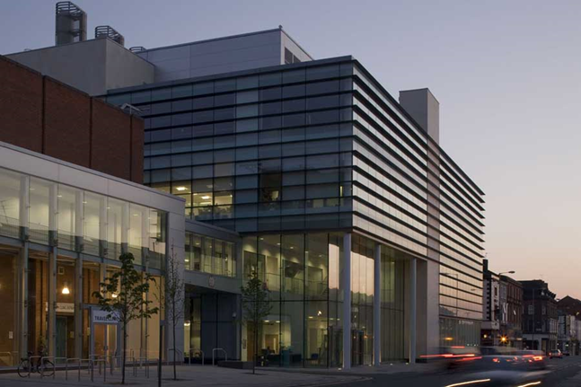
What can LSTM offer public health registrars?
As well as the competences associated with academic public health and research, LSTM can offer registrars opportunities to further develop a wide range of knowledge and skills by engaging with teaching, ethics committees, data management and analysis, project management, policy development and evaluation.
One of the areas of work likely to be of interest to public health speciality registrars is the evidence synthesis for global health. This group undertakes systematic reviews of research evidence to inform public health policy and practice. Several public health specialty registrars have gained experience in undertaking a systematic review and publishing a paper in a peer reviewed journal.
LSTM is keen to support public health specialty registrars interested in gaining experience in international or global public health and several projects are offered.
The list of projects is renewed every year. Examples of projects available recently include;

Unintended consequences of introducing household HIV self-testing (HIVST) in Zimbabwe, Malawi and Zambia: is there potential for harm to children and vulnerable adults?
- Operational modelling in service re-design and uptake of health care interventions for MDR-TB treatment
- Analysis of health systems drivers that influence malaria elimination success within and across regions
- Asthma communication during pregnancy
Some projects involve overseas travel, whilst others are based in Liverpool. Most can be modified to suit your own needs. If you are interested, come and talk to us.
Lead trainer is Mary Lyons, email: mary.lyons@lstmed.ac.uk
More about the various departments and the work they do is available on our website; www.lstmed.ac.uk/about
We only take registrars who have completed part A.

