TRAINING PROSPECTUS

Manchester NHS Foundation Trust

Introduction to Manchester NHS Foundation Trust

Manchester NHS FT is the largest acute Trust in England, employing c. 28,000 staff. The Trust is responsible for running a family of 10 hospitals/ managed clinical services across six separate sites, providing a wide range of services from comprehensive local general hospital care through to highly specialised regional and national services. The Trust is the main provider of hospital care to approximately 750,000 people in Manchester and Trafford and the single biggest provider of specialised services in the North West of England. MFT has some of the leading clinicians in the country and is a university hospital trust with well established research links.

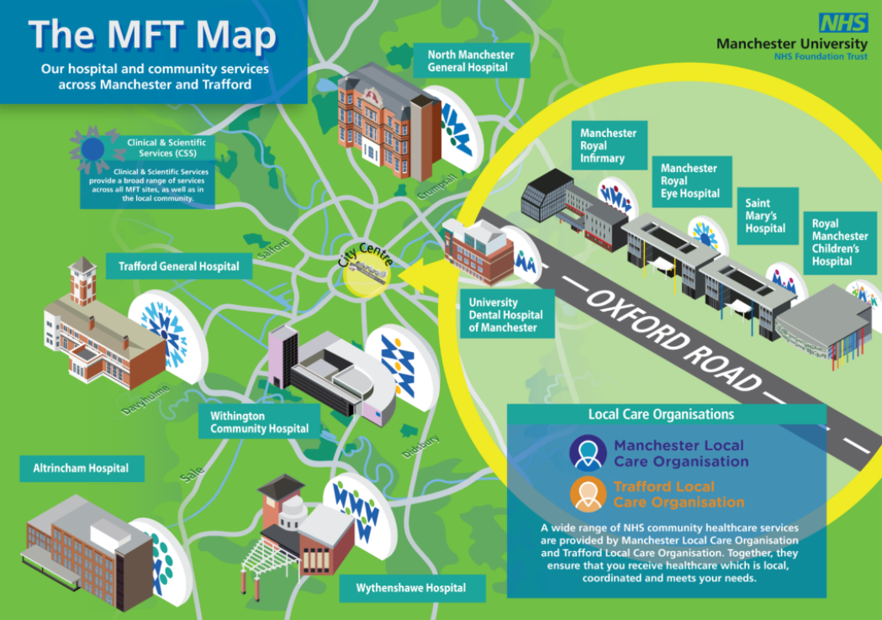

In terms of need, Manchester has some of the worst health inequalities in England, with health outcomes for some populations groups in the region being particularly poor.

MFT recently launched a new Electronic patient record (EPR) and how data and evidence can be used to inform and drive service improvements is core to the Trust’s long term strategy. The EPR has significantly improved the demographic information available to the Trust which is particularly helpful for public health work.

Link to latest annual report for more information on the Trust: https://mft.nhs.uk/app/uploads/2022/08/Annual-Report-Annual-Accounts-Final-04.07.22-compressed.pdf

Potential Placement Opportunities

MFT is a large hospital Trust which has only had a recent influx of public health specialist support, and therefore the opportunities for further public health work are significant and can be shaped around the needs of the individual and shaped around your areas of interest. Some potential projects/programmes of work, based on the current registrar’s experience include:

- Health inequalities plan development and delivery, building on the work completed during 2022/23.
- Embedding Public Health within Trust strategies
- Wider workforce development around public health
- Leading on aspects of the population health management agenda in collaboration with Manchester/Trafford Local Care Organisations
- Further developing the Trust’s business intelligence relating to health inequalities.
- Maximising the public health opportunities from the Trust’s new electronic patient record and the “social determinants of health” module.
- Pathway specific work on prevention and health inequalities
- Further embedding resident and patient voice within the Trust
- Health literacy and improving how the Trust’s communicates with residents
- Improving access to services: non-attendance, understanding and tackling barriers to access
- Collaborating with primary care around prevention and how we can use acute data across the system
- Board level OD around prevention/health inequalities; Trust governors
- Focus on wider determinants of health, e.g. continuing to develop the Trust’s inhouse Citizens Advice offer, links housing support, early help and how we can strengthen links with the Trust.

Given the relatively limited public health specialist input into the Trust there is the opportunity to work at a senior level (working closely with the group medical director) and take on responsibility for programmes of work if that meets the registrar’s development needs.

Public Health Resource within the Trust
At the time of writing there is one full time substantive Public Health consultant (who would be the ES) and one SpR placed with MFT. There is one other band 7 post working in the public health team who leads on community engagement. From August-24 there will also be two enhanced track FY1/FY2 trainees who will be linked to the Public Health team.

While it is a small public health team within the Trust, working collaboratively with the strategy and transformation teams, informatics and the equality, diversity and inclusion team has enabled registrars to deliver significant pieces of work.
This a large Trust and as such as a wide range of opportunities for public health work which can be shaped around the individual.

Link Manchester and Trafford Population Health Team
Links between the public health team at MFT and Manchester and Trafford council’s public health teams are strong and there is collaboration on a number of pieces of work. Depending on the needs and interests of the registrar, a cross system project may be available for the registrar to lead on.

Links to the university
MFT is a university teaching hospital and has well established links to Manchester University and the NIHR Applied Research Collaboration Greater Manchester (ARC-GM). Establishing relationships with academic colleagues is encouraged and has been beneficial in informing operational work and in exploring public health research questions of interest.

Teaching opportunities
There are a number of teaching opportunities within the Trust given the range of non-public health professionals (including other registrars) within the Trust.

Flexible Working
Less than full time placements can very much be accommodated.
Remote working is practical given the multi-site nature of the Trust though site visits will be required at times; equally, office space is available and registrars can work full time in the office if they wish. There is also the option to work flexibly at Manchester or Trafford town halls, with the MFT Consultant in Public Health being based between those locations one day per week on average.

Supervision
Supervision will be provided by MFT’s substantive Consultant in Public Health.

Facilities
The Trust has excellent facilities for cycling with bike storage and showers available. Office space will be at the Trust’s Oxford Road headquarters which is easily accessed by public transport or walking/cycling from Manchester city centre.
Wider hospital sites can be accessed easily by public transport.

Contact name, telephone number and email address
For any further information please contact:
Consultant in Public Health Simon Watts, simon.watts@mft.nhs.uk, 07768 864225
Current SpR: Rachel Fardon, Rachel.Fardon@mft.nhs.uk

