TRAINING PROSPECTUS - 2024

Manchester Public Health Department

Manchester City Council

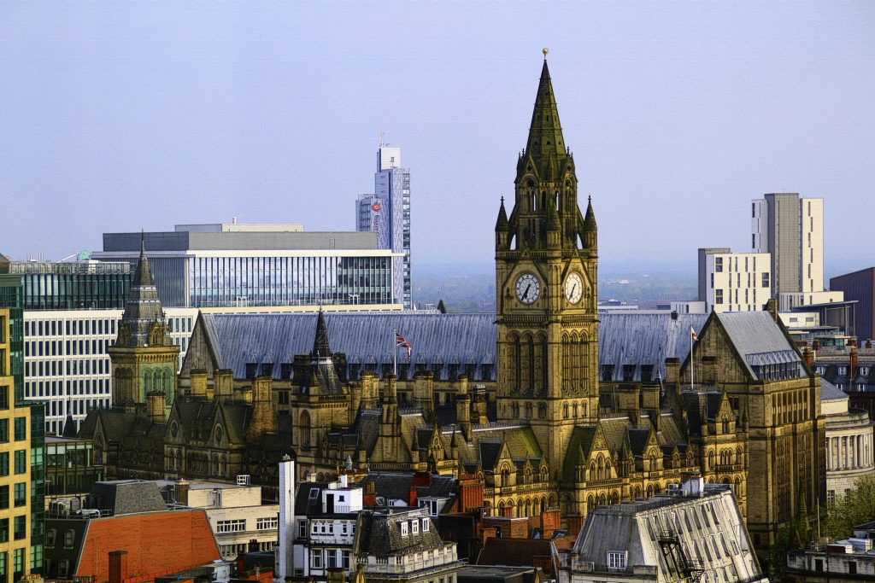

Introduction to Manchester
Manchester is the main shopping, entertainment, and commercial centre for Greater Manchester, with a thriving nightlife, excellent transport links, and world-renowned universities. However, there are very high levels of deprivation with the health of people in Manchester generally worse than the England average. Manchester’s residents have also been disproportionately adversely affected by the COVID-19 pandemic. Existing inequalities have deepened across all age groups and particularly for our most deprived communities; Black, Asian and minority ethnic communities, and those already living in poverty.

The life expectancy for men in Manchester is 74, and for women it is 79. Men can expect to die nearly 5 years younger than the average for England and women can expect to die nearly 4 years younger. In addition, life expectancy varies by 8 years between the most and least deprived communities within the city itself.

The population has increased by 9.7% (England, 6.6% and the North-West, 5.2%), from around 503,100 in 2011 to 552,000 in 2021. The percentage of people under the age of 15 years in Manchester is 19.4%, 71.1% of people are between the age of 15-64 years and 9.4% of people are over the age of 65 years. Over the next 10 years, the resident population of Manchester is projected to increase. Forecasts produced by the City Council suggest that the city's population will surpass 635,000 by 2025 and that there will be around 662,000 people living in the city by 2028.
The population is increasing in diversity (51% non-white British) speaking a total of 94 languages.

Manchester health and social care system
Manchester has undergone a major system change establishing the Manchester Local Care Organisation (LCO), responsible for improved population health outcomes and more efficient use of health and social care resources centred on 13 neighbourhoods in the city and forming a Single Hospital Service (SHS)- Manchester University NHS Foundation Trust (MFT)- for the city.

The 2020 re-fresh of the Locality Plan maintained the five strategic aims for the city:
- Improve the health and wellbeing of people of Manchester
- Strengthen the social determinants of health and promote healthy lifestyles
- Ensure services are safe, equitable and of a high standard with less variation
- Enable people and communities to be active partners in their health and wellbeing
- Achieve a sustainable system.

The Greater Manchester Integrated Care System was established in July 2022 with
four aims:
- Improve outcomes in population health and healthcare
- Tackle inequalities in outcomes, experience and access
- Enhance productivity and value for money
- Help the NHS support broader social and economic development.

Making Manchester Fairer
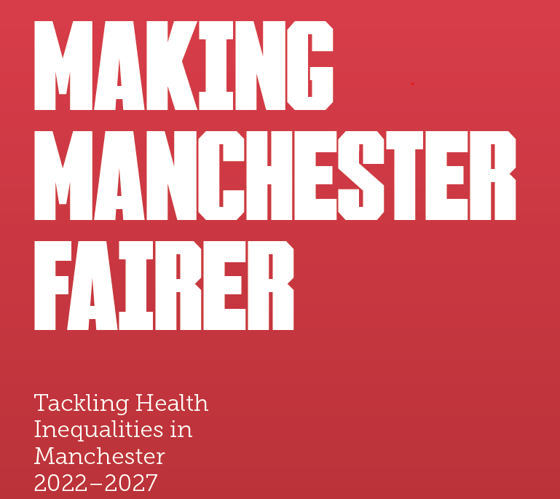

The impact of the COVID-19 pandemic on Manchester has included damaging longer-term economic, social and health effects which are expected to further impact on health and widen inequalities. These effects include strains in public finances, affecting community and environmental conditions; widening inequalities in attendance and attainment in education and early years; increasing poverty, debt and income inequality; rising unemployment, particularly for young and older people; deteriorating mental health for all age groups, but particularly for young people. These effects are likely to be compounded for people from Black, Asian and Minority Ethnic (BAME) groups, disabled people, older people, women and those on low incomes. In turn, these effects are likely to be further compounded for those living in low-income areas.

Following the publication of Professor Sir Michael Marmot’s “Build Back Fairer in Greater Manchester: Health Equity and Dignified Lives” in June 2021, Manchester gave a commitment to consider the recommendations and develop a local response.

Making Manchester Fairer- Tackling Health Inequalities in Manchester 2022-27 describes the actions Manchester will take to reduce health inequalities over the next 5 years in response to the Marmot Review for Greater Manchester and the specific needs of Manchester’s residents in light of the COVID-19 pandemic​.

The plan identifies eight areas of action:
- Giving children and young people the best start in life
- Lifting low-income households out of poverty and debt
- Cutting unemployment and creating good jobs
- Preventing illness and early death from big killers- heart disease, lung disease, diabetes and cancer
- Improving housing and creating safe, warm and affordable homes
- Improving our environment and surroundings in the areas where we live, transport, and tackling climate change
- Fighting systemic and structural discrimination and racism
- Strengthening community power and social connections

This action plan also provides a structure for greater collaboration between multi-agency and cross sectoral partnerships to mobilise organisations to place health equity at the heart of governance, policy development, resource allocation, workforce planning and commissioning arrangements.

Manchester Public Health Department
Manchester has a large department of approximately 65 staff, made up of the Director of Public Health, four Assistant Directors of Public Health (one acting as Deputy), six Strategic Leads, a Lead Nurse for Health Protection and a Head of Health Intelligence. We have a range of Programme Leads/Commissioning Managers and Project Managers leading work on the city’s public health priorities across the life course and the domains of public health – Health Protection and Healthy Environments, Health Improvement and Wellbeing and Healthcare Public Health and Partnerships.

Specialist Infection Control Nurses and Practitioners in our Community Health Protection Team are inhouse and are part of a wider Health Protection Team in Public Health which includes strategic roles.

We commission a range of services including Wellbeing, Drug and Alcohol, Sexual Health and Children’s Public Health Services.

Through our leadership, involvement and contribution to both the Manchester Locality Plan and the Making Manchester Fairer Action Plan for the city we can offer opportunities to develop the competencies required from the Public Health training Programme.

Internal and external links
We have good links and relationships with other City Council directorates and services, and we encourage and support trainees to work across the City Council, NHS bodies, and other external agencies including the voluntary and community sector.

Links to academic units
There is a high level of research advice and experience available within the team and we have a strong track record of academic collaboration e.g. Age Friendly Manchester with the University of Manchester and Manchester Metropolitan University.
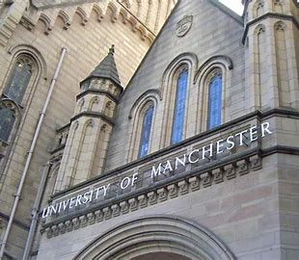

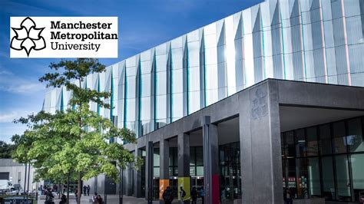

Particular interests and training opportunities
We believe that in Manchester we can meet most interests (except for managing the problems of the rural poor!). There are many opportunities to work across a wide range of topics whilst developing the skills and competencies that will support the development of a portfolio of evidence to support taking up a career in Public Health.

Organisation of training
Sarah Doran is our Lead Trainer, with two further Educational Supervisors - Cordelle Ofori and a vacant Consultant post that we expect to be qualified to support trainees. We try to ensure that trainees are stretched and supported, and that they are given opportunities, especially in the later stages of training, to lead on strategic areas of the public health programme.

Examples of trainees’ projects and experiences

Simon Watts (2022-23)
During my ST5 year I have been placed between Manchester NHS FT and Manchester City Council Public Health Department with a focus on Healthcare Public Health and health inequalities.

I have really enjoyed my experience and there are lots of interesting placement opportunities for future registrars within the Council, particularly around the Health Inequalities agenda through the Make Manchester Fairer programme. This programme has a wider determinant focus as well as the providing the opportunity to influence how health screening, diagnostic and treatment services are provided across the city working with the Local Care Organisation and Manchester NHS FT.

The Public Health Department has also led on innovative work around community engagement and co-design which has been sustained and further developed since COVID-19, making it an interesting place to practice public health, aligning priorities to resident’s needs.

I was able to take part in the senior management meetings and deputised for consultants at system partnership boards which has provided me with senior level exposure and experience.

The placement has been flexible in terms of office working vs remote working, with a lot of the team in on a particular day of the week which has allowed me to make better connections with people in the team.

Laura Parker (2022-2024)
I have really enjoyed my placement at Manchester City Council (MCC) which has been for my ST1 and ST2 years of training. I adopted a hybrid working schedule, whereby I worked 2-3 days in the office (most often Tues – Thurs as this was when most other people were in the office) and 1-2 days from home each week. I had a scheduled monthly face-to-face meeting with my educational supervisor but was also able to arrange additional meetings with my supervisor or other departmental members if I needed more advice or support.

During my time at MCC, I have been able to undertake several pieces of work addressing a broad range of learning outcomes, outlined below.

I worked on a joint strategic needs assessment (JSNA) for the Gypsy, Roma, and Traveller communities living in Manchester. This piece of work allowed me to undertake community engagement with the local Roma communities in Greater Manchester through already established connections to VCSE groups. This ensured the lived experience of the Roma community was considered as part of the needs assessment and allowed me to use creative methods, such as photovoice, to better understand the issues that are important to the Roma community. Opportunities for action identified in the JSNA were aligned to Making Manchester Fairer Objectives, allowing me to link in to pre-existing work streams to tackle health inequalities and further consolidate my learning in this area.

I also worked with closely with colleagues to review alcohol license applications and submit representations against applications that are likely to compromise licensing objectives. The representations submitted are evidence based, supported by research findings and locally available data, and have thus involved close collaboration with data intelligence and licensing colleagues. This work has provided me with the opportunity to attend a licence hearing and successfully argue against the approval of an application for an off-licence to sell alcohol a 24-hours a day. It has also allowed me to engage in direct negotiations with applicants to encourage them to adopt model conditions to ensure the alcohol-related harm of any licences granted were minimised. This led to further opportunities in the department to contribute to a report on tackling alcohol harm and to attend the Greater Manchester Alcohol Strategy meeting.

The department have encouraged me to pursue my areas of interest and have supported me in taking on work specifically linked to climate change and air pollution. I compiled a report on the health impacts of climate change that was presented to the health scrutiny committee, and I am now in the process of developing an Adverse Weather Event Plan that will combine existing flooding and cold weather plans with a new emergency heatwave plan.

Lastly, MCC has well established links with local health services, such as the Manchester University Hospitals NHS Foundation Trust (MFT). This has allowed me to start collaboratively working with NHS colleagues on several projects. These include; a project exploring the equity of pharmacy services provision in North Manchester, a project evaluating the impact of a close-relative midwife role in Longsight, and a project to better understand the relationship between air pollution and respiratory symptoms in children.

I think MCC is a fantastic place to be early on in your training. I was able to regularly come into the office, so I was able to get to know the department and directly observe how the public health department operates within the local authority. There are also lots of opportunities to take on additional responsibilities and pursue my areas of interest. The department is incredibly friendly and supportive, and this placement has been a great introduction to working in public health.

Audit/CPD
All the Consultants are registered with the Faculty of Public Health for Continuing Professional Development. We encourage trainees to undertake audit work.

Facilities and hybrid working
All our trainees are located together with the rest of the Public Health Department in the Town Hall Extension in the city centre. The Town Hall Extension is located next to the Central Library with excellent facilities. In relation to hybrid working, we encourage 2-3 days (pro rata full time) working in the office to build relationships with other members of the team and colleagues based in the Town Hall Extension- City Council, Manchester LCO (co-located on the same floor) and NHS GM Manchester locality staff (also located in the same building).
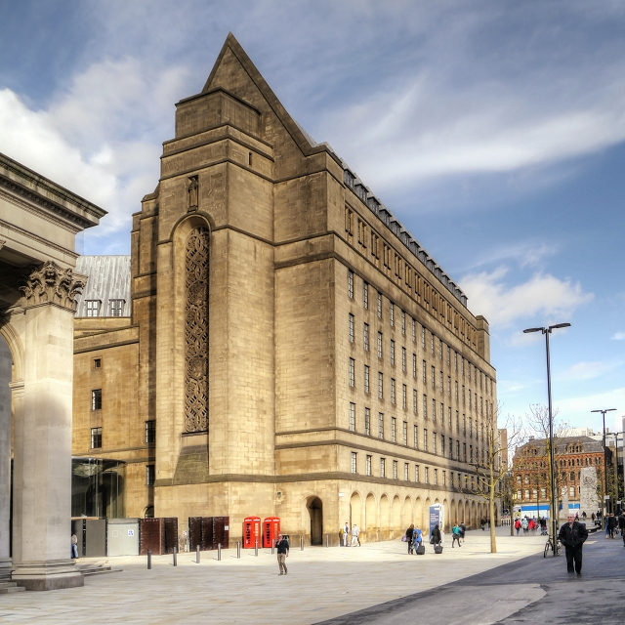

Travel options to the Public Health Department

As we are based in Manchester city centre in the Town Hall Extension, St. Peter’s Square, there are a range of options for travelling to this work placement by public transport. There are good bus connections to the city centre from across Greater Manchester, three train stations within walking distance- Oxford Road (5 minutes), Piccadilly (under 15) and Victoria (under 15)- and St. Peter’s Square Metrolink stop on the tram network. There are also secure cycling facilities, including showers, in the basement of the Town Hall Extension and several public cycle parking facilities near the building. Given the public transport facilities, and access to a taxi service when required, the placement can be undertaken without the use of a car.
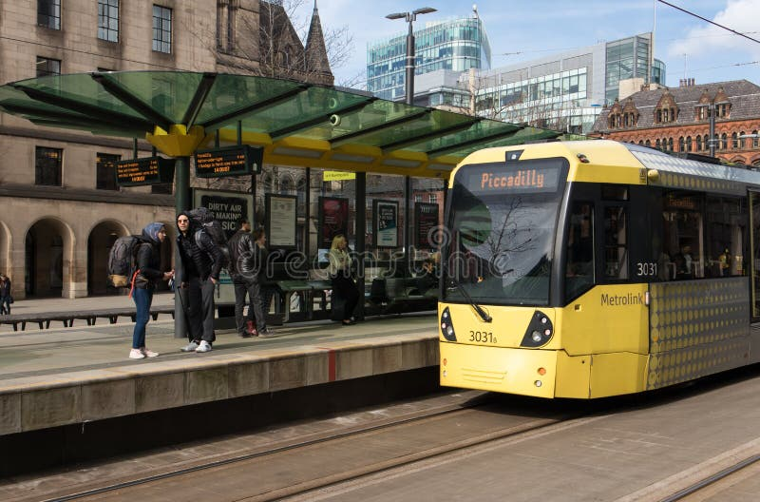

Contact name, telephone number and email address
For any further information please contact Sarah Doran, Lead Trainer, on 07976 226 866 or email sarah.doran@manchester.gov.uk

Sarah Doran, January 2024

