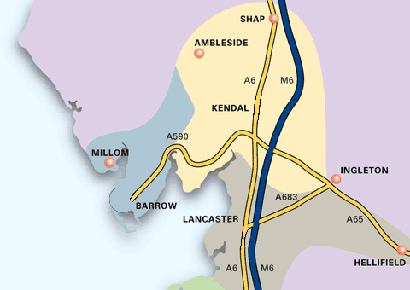

The Morecambe Bay area has a wealth of outdoor activities and the hospitals are ideally located for access to the Lake District and the Yorkshire Dales.














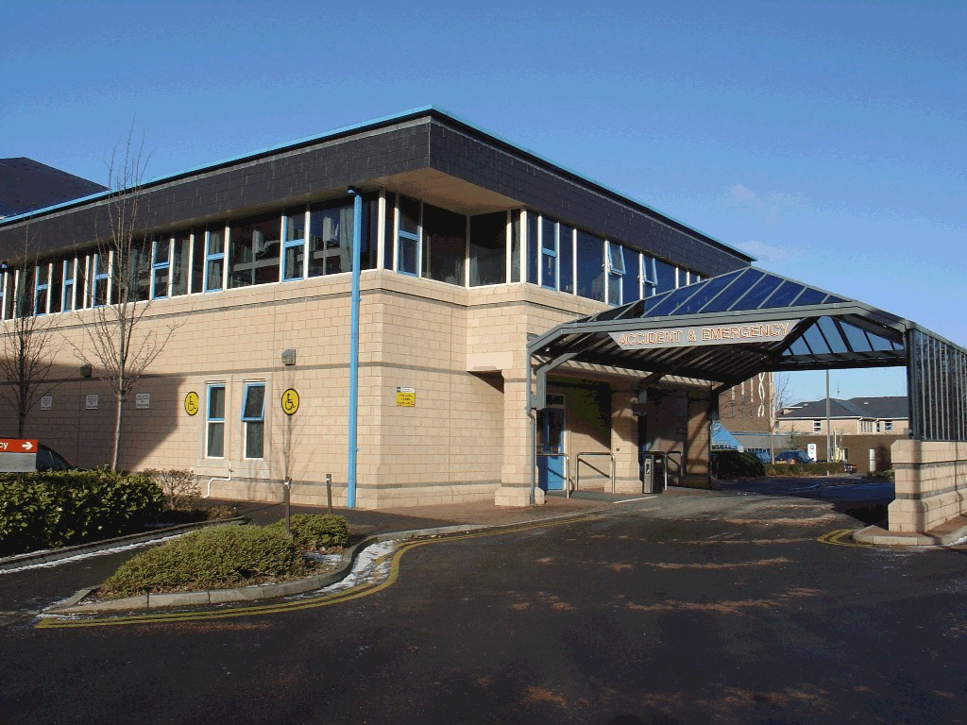
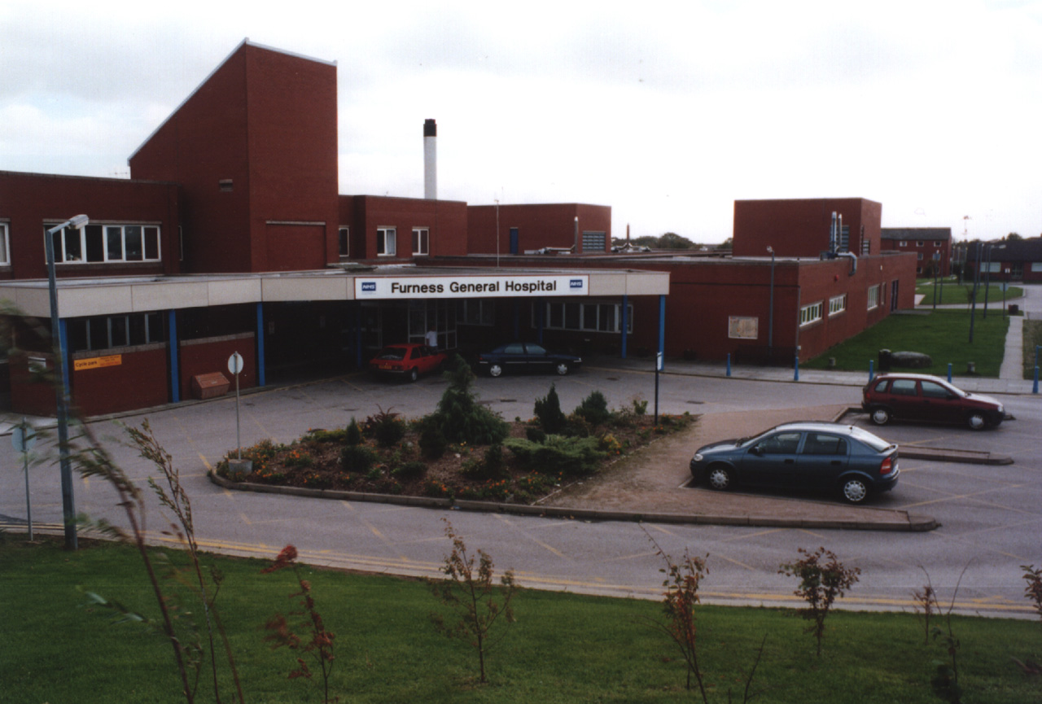
Furness General Hospital Royal Lancaster Infirmary
Dalton Lane Ashton Road
BARROW IN FURNESS LANCASTER
Cumbria LA14 4LF Lancs LA1 4RP
Tel: 01229 870870 Tel: 01524 65944

Royal Lancaster Infirmary

Introduction

University Hospitals of Morecambe Bay NHS Foundation Trust is a large organisation covering a geographical area of 1,000 square miles of a mixed urban and rural nature. The area stretches from Grasmere in the north to Garstang in the south and Barrow in Furness in the west and across the Yorkshire border to the east. There is a resident population of 310,000 and a catchment population of 350,000. The area has 17 million visitors a year, mainly to the south Lakeland area. Local health services are provided by The University Hospitals of Morecambe Bay NHS Foundation Trust, Primary Care Trusts and GPs.

The Trust operates on three sites: the Royal Lancaster Infirmary (RLI), Furness General Hospital (FGH) and Westmorland General Hospital (WGH) in Kendal. All the main clinical specialities are available across the three sites with tertiary services being accessed from Manchester, Blackpool and Preston. Each hospital offers excellent educational and clinical experience for Foundation doctors. They are modern, well equipped and friendly places to work and the clinical team has a keen interest in the teaching and welfare of junior doctors.

There is an Education Centre and Library on each site staffed during normal working hours. The libraries are well supplied with both electronic and paper resources and are accessible 24 hours a day, 7 days a week. There is a Junior Doctors’ Mess within each hospital.

There is a Foundation Year 1 Tutor and Clinical Tutor at both Lancaster and Furness hospitals. There is a Postgraduate Medical Education Manager at Furness General Hospital and at the Royal Lancaster Infirmary (who also covers Westmorland General Hospital). Representatives from these Departments attend the site based Junior Doctors Forum where all issues relating to junior doctors’ education and welfare are discussed. There is also an Occupational Health Department on each site dealing with initial pre employment health screening (proof of Vaccination/Immunisation status required) and are available for advice/support/treatment for occupational related health matters.

All Foundation Doctors will attend a comprehensive shadowing and induction programme and there are compulsory bleep-free weekly teaching sessions. In addition, each site has regular clinical meetings at lunchtimes and most specialties have weekly teaching sessions. The Foundation Tutors serve as mentors to their Foundation doctors all of whom are assigned an educational supervisor in each speciality.

The Trust is fully involved in undergraduate medical and dental education and hosts students from Liverpool and Lancaster University.

Trainees are appointed via the Deanery process. Further vacancies are filled utilising Trust based human resources team and are governed by local trust policy. Trainees will have pre start screening prior to issuing of contracts of employment.

University Hospitals of Morecambe Bay NHS Foundation Trust

Current education staff

Interim Associate Director of Medical Education Mr J Harrison
Assistant Associate Director of Medical Education Ms C Shrimpton
Doctor in Difficulty Lead Ms C Shrimpton
Clinical Tutor, FGH Ms C Shrimpton
Clinical Tutor, RLI Dr S Bari
Academic Track Lead Dr M Bukari
FY1 Programme Director, RLI Dr T Oldham
FY1 Programme Director, FGH Drs Rachel Jolley and Cathy Hay
FY2 Programme Director Dr J Harrison
GPST Director, RLI Dr S Frost
GPST Director, FGH Dr D Waind
Education Centre Manager RLI & WGH Ms L Benson
FGH Mrs L Woodhouse
Foundation Programme Administrator FY1, FGH Miss K Oxley
FY1, RLI Miss L Brady
FY2 both sites Miss S Salehi
Speciality Administrator RLI Mrs P Artingstoll
FGH Mrs J Smith
GPST Administrator RLI Mrs P Artingstoll
FGH Mrs J Smith
Oversees Tutor RLI Dr S Bari
FGH Dr Maleki
Careers Tutor Dr Jeremy Harrison

Furness General Hospital (FGH)

Barrow in Furness is a large town located in South Cumbria with easy access to the popular Lake District. The hospital is about 2 miles from the centre of Barrow in Furness and the railway station and is close to the historic ruins of Furness Abbey. There are the usual range of high street shops bars, clubs and restaurants, sports centres and cinema complexes. Barrow Cricket Club is adjacent to the hospital and social members are welcome. There are two Tesco stores (one 24hours) plus a large 24 hour Asda about 1 mile from the hospital.

Access to the Lake District is easy from Barrow with the south western fells being relatively close and clearly visible from the hospital. The market town of Ulverston is about 10 miles away and it is half an hour’s drive to Coniston and Bowness. Access to the M6 has greatly improved with the opening of a new bypass early in 2008.

The hospital is a modern facility that opened in 1984 (390 beds). The clinical services provided at FGH include:

Accident and Emergency General Surgery
Acute General Medicine Ophthalmology
Elderly Medicine Upper and Lower GI Surgery
Cardiology Urology
Gastroenterology Renal Medicine
Dermatology Obstetrics and Gynaecology
Rheumatology Paediatrics
Haematology Intensive Care
Oncology High Dependency
ENT Maxillo-Facial Surgery
Pain Management Palliative Medicine

The hospital benefits from a comprehensive range of supportive diagnostic and therapeutic services including CT scanning and MRI.

The Education Centre and Library are accessible from within the hospital, the Library being available 24 hrs a day 7 days a week. A Clinical Skills Laboratory and trainers are available to teach and assess clinical skills according to individual needs. As well as central tutorial rooms and tiered lecture theatre they are near patient seminar rooms within wards and departments.

Teaching Provision

The Foundation Director and Clinical Tutor, supported by the Education Centre staff, are responsible for the education and welfare of the Foundation doctors. A sample of typical week’s educational and teaching events is shown below.

Weekly Educational Programme FGH

 | TIME | TOPIC
MON | 13:00 –13:30 | Medical Case Presentations
TUE | 09:00 - 17:00  (alternate weeks)  08:00 – 09:00  08:30 – 10:00  12:30 – 14:00  12:30 – 14:00  14:30 – 17:00 | FY2 Teaching at FGH/RLI  Orthopaedic Case Presentations  ENT (Video Conferencing)  Ophthalmology Teaching  Peer Led Medical Teaching  Lymphoma
WED | 12:30 – 13:15  12:30 – 13:30  14:00 – 16:00 | Multi-disciplinary Lecture Grand Round  Colposcopy  GPST Programme Teaching
THU | 08:30 – 10:00  09:30 – 11:30  12:00 – 14:00  12:30 – 13:30  12:30 – 13:30  12:30 – 15:00  14:00 – 16:00  13:00 – 15:00  16:00 – 17:00  (Monthly) | Obs & Gynae (MDT)  E&D Department Teaching  Lung Cancer (MDT)  Obs & Gynae Department Tutorial  ENT Tutorial  Paediatric Tutorial  Colorectal (MDT)  FY1 Tutorial  Oncology (MDT)  Radiology
FRI | 11:15 – 14:00  13:00 – 14:00  14:00 – 17:00 | Upper GI (MDT)  FY1 Tutorial  Urology (MDT)

General Surgery, Urology, Orthopaedic Surgery and Anaesthetics attend a rolling half-day session once each month, which includes case presentations, journal review and clinical audit.

General Medicine hold half-day clinical audit sessions once a month.

Liberated learning is encouraged throughout the hospital.

Royal Lancaster Infirmary (RLI)

Lancaster is a small city with two highly regarded universities and is consequently popular with students. The RLI is about 5 minutes walk from the City Centre. The railway station is in the centre of the city as are bars, restaurants, clubs, theatres etc, Sainsbury’s and the usual high street shops. The sports centre and Asda (24 hour) are on the outskirts of the city centre. Lancaster has a mosque and there is also a synagogue within Lancaster University grounds (2 miles away). The Lake District is relatively close to Lancaster (32 miles to Windermere) and there is easy access to the Yorkshire Dales. Lancaster is 4 miles away from the regenerated coastal resort of Morecambe.

The hospital has approximately 500 beds. The clinical services provided at RLI include:

Accident and Emergency General Surgery
Acute General Medicine Ophthalmology
Care of the Elderly Upper and Lower GI Surgery
Cardiology Urology
Gastroenterology Vascular Surgery
Dermatology Obstetrics and Gynaecology
Rheumatology Paediatrics
Hepatology Intensive Care
High Dependency Diabetes/Endocrinology
Coronary Care Breast Surgery
ENT Orthodontics
Palliative Medicine Restorative Dentistry

There are a comprehensive range of supportive diagnostic and therapeutic services including CT scanning and MRI.

Teaching Provision

The Foundation Tutors, supported by the Foundation Administrator, is responsible for the education and welfare of Foundation doctors. A typical week’s education programme at RLI is shown below.

Weekly Educational Programme RLI

 | TIME | TOPIC
MON | 11.00 – 12.00  12.30 – 14.00  12.30 – 15.00  13.30 – 16.30  14.00 – 16.00 | Rheumatology  Medical Clinical  Breast MDT  Community Paediatrics (WGH) (Monthly)  O & G Teaching Clinic
TUE | Alternate Tuesdays  All day  08.30 – 10.00  12.30 – 15.00  12.00 – 14.00  13.00 – 14.00  13:30 – 17:00  14.00 – 16.30  14.00 – 15.30  14.15 – 17.00  Alternate Tuesdays | FY2 Teaching at FGH/RLI  CMT Regional Teaching  Head and Neck MDT  Endocrinology  Vascular Radiology  O & G CS & CTG multi-disciplinary Meeting  Paediatric Teaching  Anaesthetic Regional (Lower STs) (Tue/Thu)  FY1 Surgical Teaching (Fortnightly)  Non/Lymphoma MDT  ST Medicine Teaching
WED | All day  08.30 – 09.15  09.00 – 12.00  11.30 – 12.30  12.30 – 13.15  13.00 – 16.00  13.15 – 17.00  13.30 – 16.00 | Regional Surgical CT Teaching  X-ray meeting  Anaesthetic Regional Teaching (Higher STs)  Respiratory Journal and Educational Meetings  Hospital Grand Round (Fortnightly)  Emergency Medicine Teaching  Psychiatry Teaching  GP Lancaster Training Programme
THU | 08.00 – 11.30  08.00 – 11.00  11.00 – 12.00  12.00 – 14.00  12.30 – 13.30  12.30 – 14.00  13.00 – 17.00  14.00 – 16.00 | Gastro  Gynaecology MDT  Colposcopy  ICU multi-disciplinary meeting  ST Paediatric Teaching  Oncology Radiology  FY1 Teaching  Colorectal MDT
FRI | 08.15 – 09.00  09:00 – 10:00  10.00 – 10.30  11.15 – 13.45  13.00 – 14.00  13.30 – 14.30  14.00 – 17.00 | Gastro MDT  Local Upper GI  HPB Cancer Network  Upper GI MDT  Care of the Elderly Case Presentation  Paediatric Teaching  Urology MDT

General Surgery, Orthopaedic Surgery, Obs and Gynae, ENT, Radiology and Anaesthetics attend a rolling half-day session once each month, which includes case presentations, journal review and clinical audit.

General Medicine hold half-day clinical audit sessions once a month.

In addition to these events, each specialty provides formal and protected teaching sessions each week.

Foundation Posts in Morecambe Bay

Please refer to the North Western Deanery website for Foundation Posts. (www.nwpgmd.nhs.uk)

Tracks/Banding

Each track contains 9 posts (please see FY1 & FY2 examples below). Posts are banded subject to hours/workload. Banding will be confirmed upon appointment.

Foundation Year 1
Track 6 | Aug- Dec  Acute Internal Medicine | Dec - April  General Surgery | April - Aug  Trauma & Orthopaedics including Rheumatology
 | General Surgery | Trauma & Orthopaedics including Rheumatology | Acute Internal Medicine
 | Trauma & Orthopaedics including Rheumatology | Acute Internal Medicine | General Surgery

Foundation Year 2
Track 6 | Aug- Dec  Obstetrics & Gynaecology | Dec - April  Emergency Medicine | April - Aug  General Practice
 | Emergency Medicine | General Practice | Obstetrics & Gynaecology
 | General Practice | Obstetrics & Gynaecology | Emergency Medicine

General Practice

Each FY2 track contains a placement in general practice these are situated throughout Morecambe Bay.
During this rotation your base of work is the practice.

Study Leave

FY2 doctors in educationally approved training programmes will be eligible for study leave funding. Where relevant, and where funding is available from the budget, FPDs may procure appropriate resources (e.g. – DVDs, Course Materials, visiting lecturers…) that will benefit all of the doctors in training within their programme.

FY1s are not eligible to receive any study leave. However ‘taster days’ can be taken within the final rotation to a maximum of 5 days from their FY2 study leave budget. Formal applications forms will need to be completed.

Further Details

General Information

Please see Appendix A.

Queries

For any queries relating to Foundation Training in the University Hospitals of Morecambe Bay NHS Foundation Trust please email: Foundation.info@uhmb.nhs.uk

Visits

The Trust is not planning to hold formal open days for Foundation Training applicants however, if any individual, or groups of individuals, want to visit our hospitals, we would be delighted to organise your visit. We will arrange for you to look around, meet current Foundation doctors and talk to staff and educators who would be involved in your training. Just email the above address to arrange.

Pre Employment Screening

Following the application and scoring process all identified applicants will be required to attend a pre employment screening session at the Trust. This will comprise a short OSCE session (to assess competency in clinical skills) and a brief face to face interview.

The date and venue will be confirmed to applicants well in advance and supporting documentation will be included.

Formal appointment to posts will be subject to performance at the event and will be confirmed at the end of the session.

Key Dates

Pre-screening: 23rd April 2013 – 21st May 2013

Shadowing: 15-26 July 2013

Induction: 29-30 July 2013

Useful Links

Foundation Programme: www.foundationprogramme.nhs.uk

North Western Deanery www.nwpgmd.nhs.uk

Mersey Deanery www.merseydeanery.nhs.uk

University Hospitals of Morecambe Bay www.mbht.nhs.uk

All information is correct at time of print and may be subject to change because of changes in staff, reconfiguration of services and newly developed educational opportunities.

Appendix A

General information

Foundation doctor forums | The North West Foundation School encourages foundation doctors to contribute the regional Foundation Forum, where each year cohort in each programme is represented.  Additionally, there are national forums conducted by the UKFPO.
Educational and Clinical supervision | An educational supervisor is allocated to each foundation doctor to maintain an overview of development and progress of the doctor within the training programme. A clinical supervisor will be allocated for each placement (four month or six month) within the rotation.
Time Out of Foundation Programme (TOFP) | Foundation doctors contemplating requesting TOFP should check the relevant guidance in the Key Documents section of the UKFPO website www.foundationprogramme.nhs.uk.  Applications must be approved and signed by the local Foundation Training Programme Director and the Foundation School Director.
F2 outside the UK | Foundation School does not support or accredit doctors who wish to undertake their F2 year outside the UK.
Flexible training (Less than full time) | See North West Deanery Website. www.nwpgmd.nhs.uk
Inter Foundation School Transfer (IFST) | Foundation doctors contemplating requesting an IFST should check the relevant “Guidance for Applicants” in the Key Documents section of the UKFPO website. www.foundationprogramme.nhs.uk Applications must be approved and signed by the local Foundation Training Programme Director and the Foundation School Director.
 | Employment Information
Terms and Conditions of employment | The post is subject to the Terms and Conditions of Service of Hospital Medical and Dental Staff as modified from time to time. All staff appointments are made subject to the receipt of satisfactory references and all initial appointments to the national health service are made subject to satisfactory medical and police clearance being produced. A medical examination may be necessary on initial appointment and periodically thereafter.
Induction/shadowing | All Manchester Medical school graduates are required to undertake a mandatory shadowing fortnight in the last two weeks of July prior to commencing the actual F1 rotation.  Graduates of all other Schools are strongly urged to attend.  All F1 doctors are required to undertake a mandatory induction first two days in post (Usually first Monday and Tuesday in August) prior to commencing the F1 rotation.
Salary | The salary scale is in accordance with the current national rate and placement within the scale will be in accordance with previous reckonable service.
Annual leave | F1 doctors are entitled to 27 days annual leave in the year.  The 27 days entitlement does not include the statutory holidays. If a foundation doctor works any part of a bank holiday they are entitled to an additional days leave in lieu.  In some specialties there is some restriction on when a Foundation doctor can take their leave during the 4 months (e.g. not on their ‘hot week’ for surgery). The individual directorates will inform the Foundation doctor of any specific restrictions on when they can take leave. Leave must be booked at least 6 weeks in advance.
Visa/Work permits/Leave to remain | The Trust will consider British /EEA nationals for appointment in the first instance. If the applicant is a non-resident of the United Kingdom or European Economic Union, they are required to have a valid work visa and leave to remain in the UK, which is renewed as required. The Trust is unable to employ or continue to employ the applicant/post holder if they require but do not have a valid work visa and/or leave to remain in the UK.
Accommodation | From August 2008 F1 doctors have been required to pay for Hospital accommodation.

