NHS Greater Manchester Training Prospectus 2023-24

1. Introduction

NHS Greater Manchester offers a range of exciting professional development opportunities and experiences working as part of an integrated care system.

2. Public Health in an Integrated Care System

The Population Health directorate is led by Jane Pilkington, and the Senior Management Team (see figure 1) including two Consultants in Public Health (Dr Debs Thompson and Dr Alison Pye).

Figure 1: NHS Greater Manchester Population Health Directorate

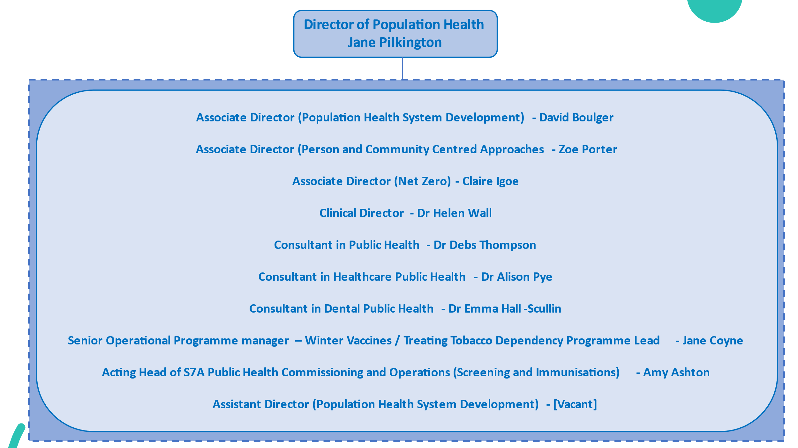

The PH teams are well connected to the Greater Manchester Combined Authority, and works closely with the policy, research and strategy teams in the reform directorate and the Mayoral teams, including the Violence Reduction Unit and Police, Fire and Crime team. The teams work successfully across partnerships to deliver a range of public health priorities:

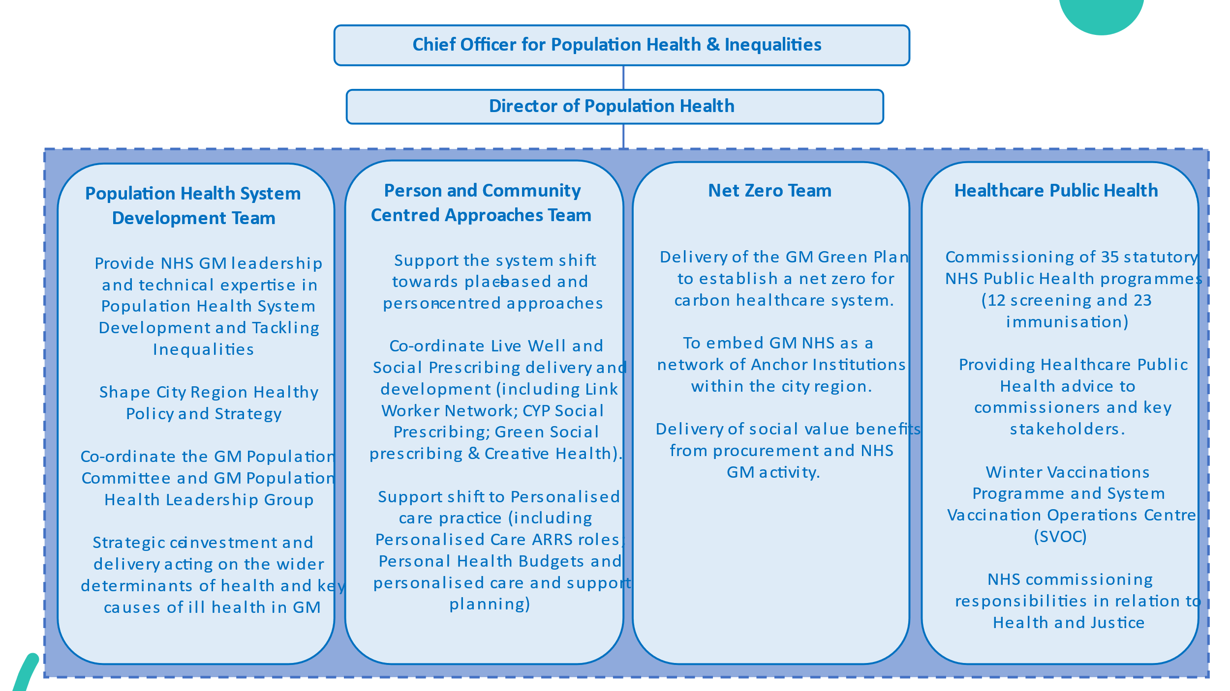

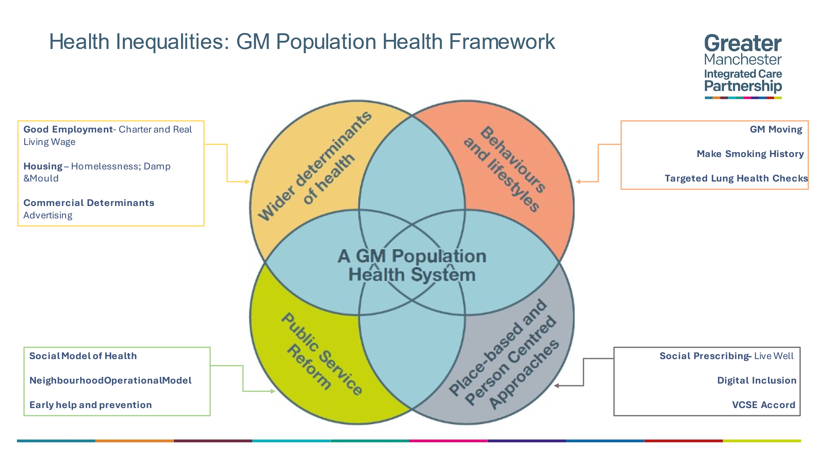
3. Location and working arrangements

The Public Health team has office space in Manchester at 3 Piccadilly Place (by Piccadilly train station) and the Tootal Building (by Oxford Road train station).

NHS GM operates a hybrid working system. The amount of time spent in the office is mostly up to the employee. The team has regular office days every other Thursday and senior management team meet consecutive Mondays in the office. The public health team has regular virtual and face-to-face meetings to keep in touch.

4. Educational Supervisor

Dr Debs Thompson and Dr Alison Pye, Consultant in Public Health, are both educational supervisors in the team.

5. Areas of opportunity

There are good opportunities to gain a range of experience in both technical pieces of work e.g. health needs assessments and health impact assessments, and in multi-agency working and commissioning. More senior registrars are able to take on leadership roles in particular areas.

6. Examples of recent StR activity

Recent projects/programmes StR have been involved in:

- Co-design of the Fairer Health for All Academy Fellowship programme
- Review of vaccination and screening programmes
- Development of Equity toolkit for Primary Care to share best practice on commissioning for inclusion and equity (in progress)
- Review of clinical and cost-effectiveness evidence to make the case for a GM-wide MECC programme
- Greater Manchester Integrated Care System Climate Adaptation Plan
- Climate adaptation rapid literature review
- Development of scoping paper on sustainable food and nutrition in the NHS in GM, to deliver on commitments in the GM Green Plan
- ITQ review and Bid evaluation for community insights work as part of HIVe programme
- Development of briefing paper for roll out of emergency department HIV/HCV opt-out testing in high prevalence areas in GM
- Smoking Cessation in Targeted Lung Health Check Options Appraisal
- Development of GM Vaping Consensus Statement
- Media briefing for Director of Pop Health
- Shadowing IFR panel
- Variation in care data report

7. Who to contact

If you are interesting in training in NHS GM please contact Debs Thompson at debs.thompson@nhs.net.

