2

North West Office

GP Specialty Training School

NEW TRAINER

And

LEARNING ENVIRONMENT

ACCREDITATION
(Please complete and email back in word format )

Trainer Name :

Practice Name/ Code:

GP Programme:

CCG:

Visitor(s):

Date:

Visitors Report: Trainer
(For GP School use only)

Summary of Findings
Areas for Development
Recommendations to GP Director
Visitor(s):

Date:

Visitors Report: Learning Environment
(For GP School use only)

Summary of Findings
Areas for Development
Recommendations to GP Director
Visitor(s):

Date:

HEE Quality Standards

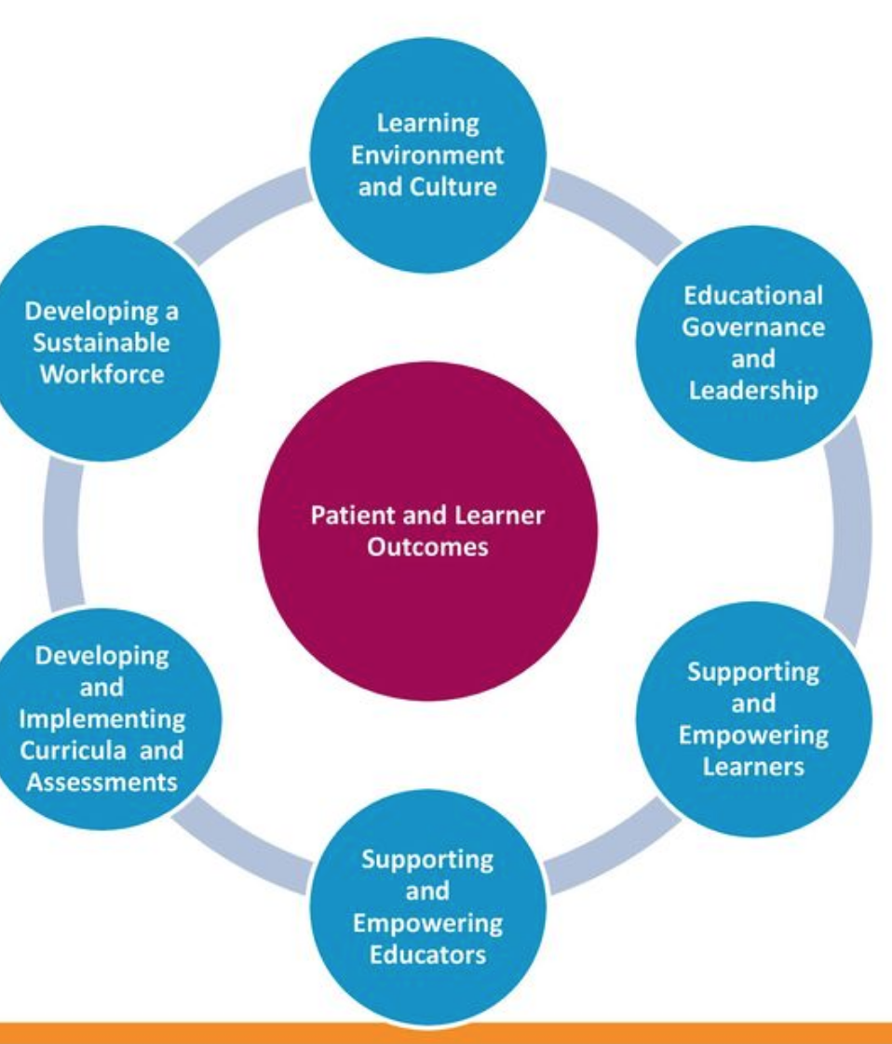

GMC Framework areas for trainer quality assurance

- Ensuring safe and effective patient care through training
- Establishing and maintaining an environment for learning
- Teaching and facilitating learning
- Enhancing learning through assessment
- Supporting and monitoring educational progress
- Guiding personal and professional development
- Continuing professional development as an educator

Mandatory Trainer Declarations

I declare that I have satisfactorily completed Equality and Diversity Training/update. (Please attach a copy or screenshot of your Equality and Diversity training certificate )
Date of Training:
I confirm that I am not under any on-going investigations or restrictions to practice from the GMC or any other Regulatory or Contracting body and that I will inform the Deputy Dean at HEE immediately of any such investigations/restrictions
I can confirm that I am progressing satisfactorily through my appraisal/revalidation cycle

(If you have answered NO to any of the above, discuss with your Associate Dean before and at the visit)

Signed: _______________________________________ ( Trainer)

Date: _______________________

The Trainer

(Q3 Supporting and empowering Educators)
Trainer Details

Name:

GMC No:

Date of Birth:

Sex:

Surgery Name:

Home address:

Home Tel:

Mobile No:

Email Address:

Date of Registration:

Qualification with Dates:

Summary of Hospital Experience:

General Practice Experience:

Registrar:

Assistant:

Principal:

Please list all medical appointments outside the practice with the hours spent on these:

Voluntary and professional organisations:

Please list research interests:

Please list publications:

Please list relevant teaching/assessment courses you have attended:

Trainer as Doctor

How long have you been in a substantive GP post?

Are you full time/part time? (if part time, indicate how many sessions)

How long have you been with the current practice?

Have you passed the MRCGP? (if yes, indicate date)

Have you been subject to any fitness to practice investigations? (if yes please give details)

Have you participated in the annual appraisal process satisfactorily?

Are you free of health problems that may hinder your commitments as a trainer?

Trainer as Teacher

When did you complete the Basic Trainers Course?

What other relevant courses have you attended?

Which Trainers Group do you attend?

How many Trainers group meetings have you attended in the past year?

Are there any educational activities you lead on in practice?

Are there any educational activities you lead on in the locality/region?

Does your personal development plan include teaching and training domains? (please specify)

Trainer
(for GP School use only: Visitors Report)

Criteria | Criteria
Trainer as Doctor | - Has relevant GP experience since qualification of over 2 years  - Has completed MRCGP  - Health and Probity self declaration complete  - Has discussed role of Trainer with the Practice team and clear plans for delivery  - Fully revalidated and participates in annual appraisal  - Has identified time within the GP workload for safe supervision and teaching (supervision slots, One to one tutorial session)  - Understands how to use practice resources and staff to facilitate GP curriculum delivery
Trainer as Teacher | - Has completed Basic Trainers Course and any allied courses on teaching and supervision  - Is conversant with the RCGP curriculum/ competency framework and the assessments within WPBA, CSA, AKT, use of eportfolio  - Is familiar with the Processes of ESR, ARCP and the Journey to CCT  - Has an understanding of GPST training programme and structures  - Has identified support systems (Trainers Group, Programme Director, local Structured Teaching Programme, Patch Associate GP Dean)  - Clear PDP for Personal development as Educator in terms of calibration and skill development  - Will ensure ongoing engagement with learner in pastoral and educational support in the role of Educational and Clinical supervisor.
Visitors Additional Comments on areas of good practice and areas for development

GPST School Criteria Met | Yes/No

The Learning Environment

(Q1 Learning Environment and Culture)

Practice Details
Practice name for database:

Surgery address:

Surgery Tel:

Practice ID number:

CCG:

Branch Surgery:

Branch Surgery Tel:

Practice Manager

Name:

Direct Tel: Mobile Number:
Email address:

Number of years in practice:

Education Manager (if different from above)

Name:

Direct Tel: Mobile Number:

Email address:

Number of years in practice:

The Clinicians (Doctors/ Nurses)

Please underline who will supervise in your absence (nominated deputy). Indicate if they any of them are involved in teaching, teaching related roles and/or if they have done teaching/supervision courses

Name of Doctor | Hours contracted | Special Interests

Practice Staff

Please list the numbers and total hours for the staff employed by the practice.

Staff Grade | Number of staff | Total Hours | Relevant Experience/Qualifications in teaching
Practice Manager(s):

Receptionist(s)/secretarial staff/IT/data entry:

Others:

Do the all the staff have PDP and educational portfolio? Yes/No (please delete accordingly)

Do all the staff undergo annual appraisal? Yes/No (please delete accordingly)

Practice Attached Staff

Please list the members of the primary health care team that are attached to the practice

Please list any teaching qualifications members of the PHCT have or teaching courses they have attended

What team meetings take place?

What other teaching/training occurs in the practice? e.g. medical students, foundation year trainees, nurses, other PHCT members

The Premises

Total list size:

Trainer’s list size (if personal lists):

Are the premises

Health centre
Rented
Practice owned
LIFT

Number of consulting rooms:

Does the GPST have own consulting room? Yes/No

Is there video recording equipment in the room? Yes/No

If not in the same building are there services accessible nearby? Yes/No

What other services are housed in the same building? (please list)

Learning Environment: Premises and services
(For GP School use only: Visitors report)

Criteria | Criteria
Premises | - Clearly identified room availability for GP Specialty Trainee to consult (preferably own room or clearly timetabled)  - There is sufficient equipment for Consulting and examining  - There is up to date equipment for videoing consultations  - The practice facilities are safe and accessible and CQC certified
Personnel  (partners with teaching skills, nominated deputy PHCT, multi-professional input) | - The Practice staff and partners will contribute to teaching and supervision  - There is clearly nominated Deputy to supervision  - There will be multi-professional input (From \Practice Nurses, Manager, IT, Reception staff) towards training  - The staff have an understanding of their roles in GP curriculum delivery, feedback, workload and safe supervision of the Learner
Services  (variety of services available and accessibility) | - The Practice has mapped out the Primary care and community services accessible for the Trainee to learn from (Pharmacy, Primary Health Care Teams, Allied clinics)  - The Practice will ensure the GPST is familiar with the whole scope of services available for them to access through induction and training resources
Visitors Additional Comments on areas of good practice and areas for development

GPST School criteria met | Yes/No

IT Systems

What is the practice computer system?

List aspects of clinical practice the computer system is used for-

Do you use an electronic appointment system? If yes, how will this aid teaching and supervision?

Are results investigations accessible through Path-links? If not what method is there to access and record lab results?

Are all hospital letters/discharge summaries/OOH sheets scanned? If not what method is there to access and record lab results?

What is the practice policy for summarising and keeping records up to date? (if there is a written policy, please enclose)

Does the practice have a website? Yes/No

If yes, what is the web address?

Are there any patient services available online? (Prescription ordering etc.)

Are there any other aspects of the IT system in your practice that you feel will aid teaching and supervision?

Write a few lines on induction into the IT systems for the GPST-
Are paper records used? Yes/No

If yes what for?

Does the practice have a branch surgery? Yes/No

Is the GPST expected to consult from the branch surgery?

(If yes fill in the following sheet – one for each branch surgery)

The Branch Surgery
(Please complete one sheet for each branch surgery)

Address:

Does the registrar ever consult from this surgery? Yes/No

How many consulting rooms are there?

Is there a computer terminal? Yes/No

Is the computer connected to the main surgery? Yes/No

Does the branch surgery have an appointment system? Yes/No

How many patients are booked to the hour?

Learning Environment: Records and IT
(For GP School use only: Visitors Report)

Criteria | Criteria
IT Systems | - The Practice IT systems are fit for purpose for daily consulting  - They are compliant with Information Governance and good standard of summarisation  - There is a clear system of digitising documents and paper communication (letters, reports etc.) contemporaneously  - There is an electronic appointment system  - The Trainee rota will clearly identify Clinical supervisor  - The Supervision slots are visible to the Trainee  - There is a Practice Website with information about Training practice for patients (or a clear plan to include the information)
Introduction to systems | - There is a structured Induction to IT  - There is help and support available throughout for use of IT  - There is plan for safe introduction to completing and perusing tasks /queries/ lab results
Monitoring of activities | - Clear plans for monitoring Caseload/ Case-mix using IT systems  - Clear systems for messaging/communicating with the supervisor and other team members  - Trainee will be included in the practice email systems and governance systems  - Trainees record keeping will be monitored and feedback given on safety, appropriateness and continuity of care  - There are systems in place for referral , prescribing and other activity audits
Visitors Additional Comments on areas of good practice and areas for development

GPST School criteria met | Yes/No

Workload

Does the practice have an appointment system? Yes/No

If yes is this electronic?

Do you provide ‘advanced access’? Yes/No

Is there an in-house on call rota for cover during working hours? Yes/No

Trainer

How many patients are booked per hour?

How many extras are added to the session on average?

Partners

How many patients are booked per hour?

How many extras are added to the session on average?

GP Specialty Trainee

How many patients are booked per hour?

How many extras are/will be added to the session on average?

Out of Hours

Which organisation provides OOH on behalf of your PCT?

What are the arrangements for OOH experience for Registrars in your area?

Do you personally undertake OOH sessions? Yes/No

If yes how often?

Learning Environment: Workload
(for GP School use only: Visitors Report)

Criteria | Comments
Trainer’s Workload: | - Trainer’s workload will be conducive to trainee support (safe numbers, extras and time for debrief)  - Safe supervision arrangements (supervision slots (minimum 3-4) identified throughout the Trainees placement)  - Clearly identified tutorial/ Structured Teaching encounter time weekly (minimum 3-4 hours – The Trainer may use some of this time for preparation & planning)
GPR case load: | - Clear plans for Trainee workload to be conducive to Learning  - Regular reviews and planned escalation of number of appointments  - Safe plans for home visits  - Workload not in breach of GPST contract or working time regulations.
Out of hours: | - Clearly identified local OOH arrangements for GPST to book  - Prospective Trainer aware of OOH competencies, requirements for completion of CCT and the necessary documentation in the e-portfolio
Visitors Additional Comments on areas of good practice and areas for development

GPST School criteria met? | Yes/No

Library and Educational Resources

Does the practice have a quiet reading room/library on site? Yes/No

If no, are there alternatives?

Please highlight broad areas/categories in which books are available-

Clinical | Yes/No | Medico Legal | Yes/No
Clinical Governance | Yes/No | Practice Management | Yes/No
IT | Yes/No | NMRCGP | Yes/No
Consultation/Communication skills | Yes/No | Teaching | Yes/No
Medical Ethics | Yes/No |  | Yes/No

Is there a policy for updating and cataloguing the library?

What policy is there for purchasing books for the GPST?

Which Journals/occasional papers are available in-house?

Is there access to electronic resources at workspace? Yes/No

If yes are they listed?

Do you use an online mentoring system for clinical practice? Yes/No

Does the GPST have access to this?

Is there a practice intranet for local resources/induction packs/protocols? Yes/No

Learning Environment: Library and Educational Resources
(for GP School use only: Visitors Report)

Criteria | Comments
Library: | - There is an identified Library and Quiet room or a suitable alternative for Educational resources  - There is a clear policy for purchase of necessary new resources  - There is access to Digital information (Reliable online resources, Guidelines, Practice resources)  - The practice has produced a list of helpful websites that is accessible to the learner through their Desktop  - The Trainer has a clear idea of information governance, critical review and reliable evidence base
Content: | - The list of resources matches GP School  recommended list for Practice Educational resources  - There is mix of online resources and books available to cater to various GPST learning styles
Visitors Additional Comments on areas of good practice and areas for development:

GPST School Criteria met? | Yes/No

Process of Care

What was your QOF achievement in the last financial year?

Please attach QOF summary sheet if available

Does the practice provide the following services and if yes who is the lead partner?

Service | Lead
Child Health Surveillance
Minor Surgery
Family Planning

If the above services are not provided what arrangements are/will be made for the GPST to experience them?

Other allied services (please list) | Provider

Is there a practice formulary? Yes/No

Audit and Performance Review

List recent audits (please underline rolling audits with completed cycles):

Clinical

Management

List significant events audits completed in the past 12 months:

Please list any of the above audits you’ve personally undertaken or led:

Learning Environment: Audit and performance review
(for GP School use only: Visitors Report)

Criteria | Comments
Culture of Audits & SEAs in change management | - The Practice has an open culture of Audits and Performance review  - A culture of whole team participation in Significant Event Analysis  - The Practice meets safe thresholds of Quality improvement  - (QOF, Primary care standards etc)  - Meets CQC standards of Quality improvement
Audits & SEAs as teaching tools: | - The Learner will have access to Audits and SEAs  - The Learner will be able to attend meetings where they are discussed  - The Learner will be supported in developing and performing and reflecting on an audit cycle  - The Learner will be encourage to participate and reflecting on Significant event analyses.
Visitors Additional Comments on areas of good practice and areas for development:

GPST School criteria met: | Yes/No

The Educational Programme

(Q5 Developing and Implementing Curricula & Assessments)
Plan for the GP Specialty Trainee

Is there a structured induction to the practice?

Is there an employment contract in place?

Is there an educational contract in place?

Workload

What is the appointment rate for the GPST?

1-3 months:

4-6 months:

7-12 months:

Will extras be added to this list and if so how many on average?

How will you monitor the GPST case mix, workload and utilisation of services?

How often will the GPST be on-call in the practice (day time)?

Please detail what areas they would cover and what supervision they would have-

Organisation of Teaching

Please list which teaching methods would be used in the practice in order of preference (e.g. RCA, PCA, joint surgeries)-

How many hours of formal, protected teaching are allocated to teaching?

Is there additional informal teaching time? Yes/No

If yes, how is this organised?

How will chronic disease management be taught?

Do partners or staff have specific fields of expertise and how is this integrated into teaching?

Organisation of Assessment

Is the practice team familiar with the new assessment methodologies in the e-portfolio?

Assessment of the Registrar

Apart from the mandatory assessment tools (CBD/Mini CEX, COT, DOPS), please indicate the other tools which you intend to use with your registrar-

Assessment method | Never Use | Use Sometimes | Use Regularly
- MCQ
- MEQ
- Random Case Analysis
- Video Recording
- Record Review
- Joint Surgeries
- Project Work
- Patient Satisfaction Questionnaire
- 360 degree Assessments (all staff)
Other (please specify):

Which of the above methods will you use?
(Please enter numbers corresponding to methods given above: 1-9)

At the start of the training period: …………………………………..

At the mid-point of the training period: ……………………………..

At the end of the training period: ……………………………………

If ‘other’ please give details:

Educational Programme
(for GP School use only: Visitors Report)

Criteria | Comments
Organisation of teaching: | The Practice pledges:  - Dedicated time for safe teaching and supervision  - Workload of Trainer and Trainee conducive to learning and teaching  - A whole team approach to teaching and supervision with contributions from a variety of team members  - A team familiarity with the GPST curriculum and competencies  - A clear job plan for the GP Trainee
Organisation of assessment:  (e-portfolio, familiarity with assessment tools, team involvement, OOH assessments) | The Trainer and the team are familiar with:  - The GP E-portfolio and its purpose  - WPBA and the component assessments  - Clear systems of feedback and documentation of teaching  - Role of Clinical and Educational supervision  - OOH requirements and competencies
Recording of teaching and assessment : | The Trainer and Team will ensure:  - Clear records of teaching from all involved  - System for communication about the learners development and issues  - Clear understanding of educational and pastoral support  - Evidence of Education themed meetings where Trainee(s) progress is discussed  - Will seek exit feedback from all learners to shape the programme and institute any changes required if relevant  - Regular trainer/supervisor engagement with E-portfolio
Visitors Additional Comments on areas of good practice and areas for development:

GPST School criteria met: | Yes/No

Practice Development

Please outline (or enclose) key points of your practice development plan:

Please outline plans to develop (learning environment, expansion, succession planning of trainers etc):

I understand that the information provided in the application form will be processed in accordance with the Data Protection Act. Personal data relating to doctors, such as that contained in the application form, is stored in Deaneries both on computer and manual systems. Where appropriate, information is shared with those who have a responsibility for the organisation, management and delivery of training, to help them execute their function in the planning and delivery of doctors’ training.

Prospective Trainer’s Signature: Date:

Proposed Practice Timetable Proforma

Please indicate, using a letter from the key below, the activity of the practice during the week-

 | Time (e.g. 9am – 10.30am) | Trainer (1)  Name | Registrar (1) | Comments e.g. cover/teaching by partners (please specify)
MON AM 1
MON AM 2
LUNCH
MON PM 1
MON PM 2
EVENING
TUES AM 1
TUES AM 2
LUNCH
TUES PM 1
TUES PM 2
EVENING
WED AM 1
WED AM 2
LUNCH
WED PM 1
WED PM 2
EVENING
THURS AM 1
THURS AM 2
LUNCH
THURS PM 1
THURS PM 2
EVENING
FRI AM 1
FRI AM 2
LUNCH
FRI PM 1
FRI PM 2
EVENING
SAT AM 1
SAT AM 2

Key
Teaching Administration Half Day (out of practice activities etc) Visits Clinics
Surgery Team Meetings Day Release Out of Practice

Trainer Additional Comments:

