North West of England School of Foundation Training and Physician Associates
School guidance to support the NHSE (HEE) Relocation and Excess Mileage Policy

Version/Author/Publication Date | V1.JPhazey-Baines.April23
Version/Author/Publication Date | V2.JPhazey-Baines.June23

This document sets out local school guidance on the reimbursement of relocation and excess mileage expenses and should be used in conjunction with the national NHSE (HEE) Relocation and Excess Mileage Policy which can be accessed here:
https://www.hee.nhs.uk/news-blogs-events/news/new-national-arrangements-payment-relocation-expenses-costs
In November 2020 (the former) HEE published new arrangements for the payment of relocation and mileage expenses for junior doctors, replacing a wide range of different arrangements and funding allocations across the country. Under the new framework, Postgraduate Doctors in Training (PGDiT) can claim up to £10,000 to cover relocation and excess mileage costs over the duration of their postgraduate training. HEE worked closely with the British Medical Association (BMA) and other stakeholders to provide a consistent approach to support all PGDiT who face financial costs of moving house to take up training, and/or may be financially disadvantaged as a result of their training programme covering a large geographical area.
Whilst the national policy sought to provide consistency it did not take account of the nuances which surround the recruitment and allocation into Foundation Training, both two-years programmes and standalone F2 programmes.
To offer further support and clarity for our Foundation community the North West School of Foundation Training and Physician Associates negotiated a set of local interpretations and agreements. This document sets out this local guidance.

F2 Standalone Programmes
The national framework stipulates that only PGDiTs on programmes of at least two-years are entitled to claim. This would typically exclude those who are appointed to F2 standalone programmes. This may include overseas applicants who have usually incurred costs to relocate to the UK to train, but it may also include UK graduates who, for whatever reason, have previously withdrawn from a Foundation training programme and are looking to return and must enter on an F2 standalone programme.

The North West school has agreed to reimburse doctors on F2 standalone programmes in line with the principles and criteria set out in the national policy and this local guidance.

Single-site programmes
The national policy states that where trainees are based on a single site programme they’re expected to live within a reasonable commutable distance and will not be entitled to claim excess mileage. Whilst our Foundation doctors are employed by single site programmes the placements within that programme may be delivered across multiple hospitals and off-site locations.
Foundation doctors in the North West will be entitled to claim excess mileage (above 17 miles) for any placements which are delivered outside of the trusts main hospital locations. For example, mental health, palliative care and public health placements.
General practice placements are funded in line with different arrangements and are covered separately in this guidance.
Foundation Doctors that are employed by a trust that has multiple hospital sites and where their two-year programme has placements at more than one of those hospital sites will also be able to claim excess mileage. They will be expected to live within a reasonable commutable distance of one of the main sites that they will be undertaking placements at and this should be considered as their base site. They will not be able to claim any mileage, excess or otherwise, for travelling to/from this base location. Excess mileage will be reimbursed for travel to/from any placements at any of the other hospital locations within that trust.

General Practice placements
The reimbursement of mileage for general practice placements is aligned to the arrangements for higher GP trainees and expenses for the full mileage between home and the principle practice location will be reimbursed, along with any associated costs, such as home visits. The rate of reimbursement for expenses related to GP placements is 28p per mile (see below).

Mileage rates of reimbursement
The rates of reimbursement, with which we adhere to, are detailed on the BMA website through this link:
https://www.bma.org.uk/pay-and-contracts/pay/expenses/travel-expenses-for-doctors
Excess mileage is paid against the standard car user rates and is subject to miles travelled and engine capacity.
Mileage for GP placements is paid at a rate of 28p per mile under the 2016 contract arrangements.
Trusts may have their own rates for business miles travelled and/or other categories of rates which employees can claim expenses against. In this instance any local variations or additions to the rates covered by the BMA should be discussed and applied locally with appropriate HR involvement.
Relocation rates of reimbursement
Point 26 of the national policy states that PGDiTs can claim removal of furniture and effects (up to a maximum of £500) and for expenses related to a search for accommodation. Preliminary visit expenses can be claimed in addition to the £500 for the removal of furniture. The rate of reimbursement for higher PGDiTs is guided by the NHS Terms & Conditions of Service Handbook. As we do not follow the Lead Employer model in Foundation local trusts may use their own polices to determine rates of reimbursement. Where this is not applicable/available, the rates detailed in the service handbook are advised.
They are covered below in Table 1.

Table 1
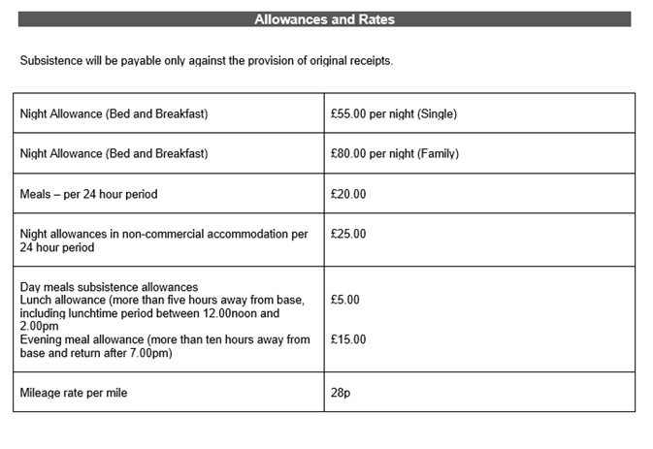
Additional notes

- Excess mileage is only applicable to individual journeys. Therefore, claims for excess mileage should be calculated from home to placement location, minus the 17 miles and then placement location to home, minus the 17 miles.

- Claims must be submitted by the Foundation doctor to the trust within 3 months of the expense being incurred.

- Parking expenses will be reimbursed for placements other than at the base site, irrespective of whether the placement is in excess of 17 miles.

- Foundation doctors in the North West can claim reimbursement of Mersey Tunnel and Mersey Gateway Bridge toll charges.

Payment Process
Foundation doctors should submit claims to the employing trust through whatever the local process is for claiming expenses. The Foundation Programme Director(s)/Associate Foundation Programme Director(s) are responsible for reviewing the claim in line with the national framework and this local guidance.
Once approved the trust should directly reimburse the Foundation doctor through local mechanisms and then seek to claim this back from the school.

The school will request a summary of claims in each quarter, around June, September, December and March time and these will be collated for payment through the Education Contracts. When submitting claims to the school trusts will be required to provide the doctors name, GMC number, cost of claim(s) and brief description of the expenses incurred, e.g., travel expenses for GP placement.

Trusts are asked to review the policy and guidance documents in the first instance for help with any enquiries.
Any further enquiries not answered by the documents available should be directed to foundation.nw@hee.nhs.uk

