Public Health Training Scheme - Training Location Prospectus

An Overview of Salford
The city of Salford is home to about 240,000 people and covers 37 square miles. There are five districts: Salford, Eccles, Worsley, Irlam and Cadishead, and Swinton and Pendlebury. Over half the city is made up of green spaces and features forests, nature reserves, mosslands, parklands and picturesque villages. There are hundreds of acres of beautiful park with a variety of wildlife habitats.
In 2015 Salford was the 22nd most deprived Local Authority out of 326 in England, and the 3rd most deprived Local Authority in Greater Manchester. About 26% (12,200) of children live in low income families. However, deprivation in many areas has been falling as a result of population growth associated with recent building projects such as Media City UK. Over half of the small areas (LSOAs) in Salford saw a relative improvement in deprivation between 2010 and 2015 – only a quarter became more deprived.
Salford’s population has been growing consistently since 2001. Most of this growth is centred in Ordsall and other inner-city areas where there have been significant investments and new developments. The age profile is also changing, with a noticeable increase in numbers of children and young adults. This trend is set to continue (as shown below) at a rate noticeably faster than the average rate for England or Greater Manchester.
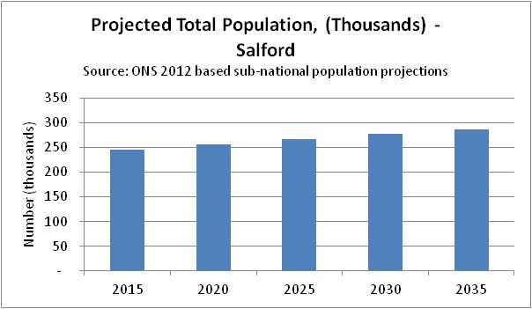
There is an increasing Black and Minority Ethnic (BME) population which more than doubled between 2001 and 2011 when it numbered 36,488. The largest ethnic groups are White Other (10,300) and Black African (5,400). There is also a large Jewish population, centred in the Kersal area which numbers 7,687 residents and represents the 8th largest Jewish population in Great Britain.

Health in Salford
Life expectancy rates for both men (76.7 years) and women (80.7 years) are significantly lower than the England average. There are also profound health inequalities within Salford with life expectancy being 11.5 years lower for men and 9.1 years lower for women in the most deprived areas of Salford compared to the least deprived areas (PHE Health Profile 2016)
The health and wellbeing of children in Salford is generally worse than the England average, including levels of teenage pregnancy, alcohol-specific hospital admissions, GCSE attainment, breastfeeding, obesity and smoking at time of delivery. Infant and child mortality rates are similar to the England average.
In 2012, 27.0% of adults were classified as obese. Estimated levels of adult smoking, physical activity and STI reporting are worse than the average for England, as are rates of alcohol-related hospital admissions. Despite these risk factors, Salford has seen a gradual reduction in heart disease, stroke and cancer over the last decade.

Salford City Council
The council's mission statement is "to create the best possible quality of life for the people of Salford."
Salford City Council comprises 20 electoral wards with three councillors representing each ward. The city council is currently controlled by the Labour party. Uniquely in Greater Manchester, Salford has an elected Mayor, Paul Dennett. The City Mayor’s Cabinet consists of the City Mayor, his two Deputies and seven Lead Members, each of whom has an individual portfolio of responsibility.
Other councillors perform a scrutiny role as members at select committees, monitoring the way the council works and examining decisions to check they meet the needs of residents. The membership of these committees reflects the overall political composition of the whole Council.
A City Director (Jim Taylor) oversees six separate departments:
- Public Health and commissioning
- Children and adult services
- Service reform and development
- Corporate business
- Environment and community safety
- Regeneration

Health and Wellbeing Board and the Locality Plan
Salford’s Health and Wellbeing Board is chaired by the City Mayor and meets monthly. It has a number of responsibilities including the production of a Joint Strategic Needs Assessment (JSNA). In Salford, JSNA reports are produced on a regular basis according to the priorities of the HWB members.
The HWB and its partners have been required to draft a Locality Plan as part of the devolution of health and social care to Greater Manchester. The budget for health and social care has been devolved as of April 2016. Salford share of the total sum is 485 million pounds per year.
The Locality Plan outlines how this budget can be used to improve existing services can be improved, how residents can be encouraged to better look after their own health and how some of the wider determinants of health can be addressed in order to improve health and deliver services in a more cost-effective way.
Key principles of Salford’s Locality Plan are:
- More health services nearer to home
- More people in primary care
- Some hospitals will become specialised
- More tests and health checks available
- Joined up health and social care services
- Better quality housing and good job opportunities
- Voluntary and community sector organisations will become important providers of care and support in addition to - or sometimes instead of – NHS services

The Locality Plan sets a number of ambitious targets for Salford including:
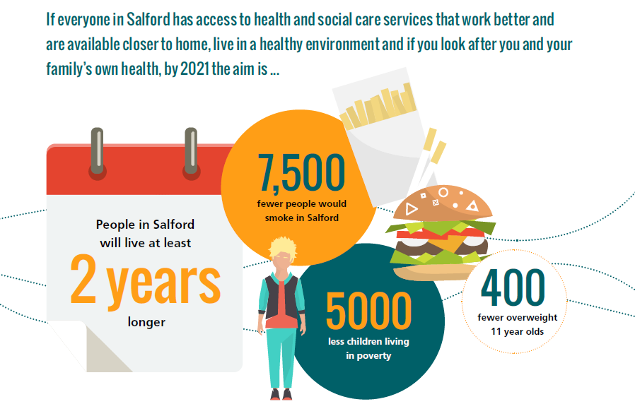

Key Partners
Salford Council has very strong links with the CCG, the acute hospital Foundation Trust (Salford Royal, who also provide the community services such as school nursing and district nursing) and a strong and vibrant voluntary sector. This makes for a really strong partnership collaboration across the City, allowing innovation. This includes the development of Salford Together, an Integrated Care Organisation leading the integration of health and social care for adults in Salford as a partnership between the CCG, Council and Salford Royal.

Academic Links
Salford has strong links with the Manchester Academic Health Sciences Network universities, especially Salford University and Manchester University. Opportunities for teaching, collaborative working on research and applied projects are possible by negotiation; a split placement may also be an option and we are actively working to develop this.

Salford City Council’s Public Health Team
The council’s Public Health, Strategy and Change team structurally integrates public health with the central policy team, who provide a broad overview of the Council’s work, including intelligence, performance management, business planning and commissioning. Around 60 team members, who have a wide variety of backgrounds, are based on the 2nd floor of Unity House, Salford Civic Centre in Swinton. Around 25 of those solely or primarily deliver the work of a traditional public health team.

Salford City Council’s Public Health Trainers
There are 3 qualified trainers at Salford: David Herne, Director of Public Health (DPH) and Ian and Ashworth and Siobhan Farmer, Consultants in Public Health.
David started working in education before moving first into local government working within Environmental Health and then within health policy in West Lancashire and Knowsley. He moved into the NHS to manage a health promotion service before qualifying as a Public Health Consultant working in South Lancashire. He moved to Salford in 2009 and was appointed to the DPH position in 2014 after acting up for the previous year. He has been a tutor for the OU and written text on health promotion and public health for a variety of post-16 courses. In addition to his role in Salford he is also DPH at Bolton Council.
Ian started his career by delivering health improvement programmes across the North West. He completed his MPH at University of Liverpool in 2009 prior to commencing the NW training programme in 2010. During specialty training, Ian has worked across Greater Manchester and more recently enjoyed practising population healthcare approaches in Liverpool Community Health NHS Trust. Ian is currently leading on public health commissioning, health improvement, integrated care for older people, the redesign of neighbourhood facing services in Salford.
Siobhan spent six years working in Health Improvement, including leading a sex education programme in Hartlepool, and then working in Healthy Schools in Redcar and Cleveland and St. Helens. She graduated from the NW Training Scheme in 2014 and now leads on Intelligence, Wider Determinants and Academic Links, as well as supporting the CCG. She holds the lead trainer role

Key Project Supervisors in Salford
As well as the consultants, the team has several key staff members who can supervise projects. In particular Debbie Blackburn leads on Public Health Nursing and Health Protection, and Debbie has oversight of the 0 to 25 year old transformation agenda. Jacquie Russell is the Assistant Director for Strategy and Change and can supervise work on policy development and business planning, as well as provide useful insight to the Local Authority governance arrangements and aspects of Commissioning such as Community Impact Assessments. Members of the team can also supervise on an ad hoc basis; for example, the Council has a strong intelligence team who can support with more epidemiologically focussed learning outcomes.

Approach to Training & Working in Salford
Trainees in Salford are very much treated as part of the team from day 1. Trainees will be located with the team, and allocated their own laptop to allow agile working in accordance with the Council’s policies.
You will attend Senior Management Team meetings with the Director which will give you an invaluable insight into operating at that senior level in the Council. You will be given projects that stretch and challenge you but that support both your needs and the needs of the team. Projects focusing on wider determinants of health may span other departments within the Council. There are also opportunities for larger pieces of work as part of larger clusters (e.g. substance misuse tender for Bolton, Salford and Trafford) or at a Greater Manchester level, linking in with the existing Greater Manchester responsibilities of the trainers.

Projects
Examples of projects undertaken include:
- Falls Review (ST1)
- BME health needs assessment (ST1)
- Commissioning for integrated substance misuse tender (ST2)
- Response to the PHE TB Strategy consultation (ST1)
- Domestic Violence Needs Assessment (ST4)
- Drug and Alcohol Needs Assessment (ST4)
- Contribution to the DPH Annual Report (ST1)
- Commissioning for Integrated Wellbeing programmes (ST3)
- Contaminated Land/ Cancer Concern Investigation (ST3)
- ‘Knowledge Nugget’ Programme Part A/B preparation (ST1/2/3)
- Homelessness Review and Commissioning Redesign (ST3)
- Public Health Financial Spend Profiling (ST3)
- Increasing Cancer Screening uptake for people with learning difficulties. (ST1/2)

What StRs Say About Salford
We receive good feedback about training in Salford. Here is a selection of quotes from StR placement reflections:
"I am thoroughly enjoying my placement at Salford City Council. Everyone in the Public Health team is enthusiastic and approachable, and I have been supported to take on interesting projects which reflect my learning needs while taking on appropriate levels of responsibility. So far during training I have been given the opportunity to lead on a Health Needs Assessment focused on ethnic minority groups in Salford and have been involved with writing policy briefings on Hospital Weekend Mortality and HIV Pre-Exposure Prophylaxis.
The Public Health department is really well-integrated within the Council and there are opportunities to work collaboratively with other departments on projects addressing the social determinants of health. There are also strong relationships with Salford CCG, linked to more healthcare-orientated projects, and links to Greater Manchester structures with an ongoing focus on Devo-Manc and its impact on Salford."
“Salford has a warm and welcoming public health team, who can provide challenge and support in equally large measures. Three consultants, including two who have recently qualified, create a strong focus on personal development within the context of the wide-ranging work of the department, helping trainees meet their learning outcomes and supporting first year trainees as they complete the Masters in Public Health. The team has excellent relationships across the council and with the CCG, and also works collaboratively with Bolton’s public health team.
After an excellent and varied induction that involved plenty of experiences outside the office environment, I have been working on a review of falls prevention in Salford. This has provided a great introduction to a range of organisations working in health and social care within the city and encouraged me to develop a style of writing appropriate for Public Health. This has also provided an opportunity to produce a briefing for councillors advocating a change to commissioning arrangements. Projects have been focussed on areas in which tangible changes to service provision can be made as a result of my work”
“Salford has been a really enjoyable, challenging and rewarding place to work from both a learning and experience perspective. From the outset I felt part of the team and have come to feel like a valued and integral member of the PH department rather than a temporary member of staff. It is a very friendly and collaborative department which emits a sense of drive and passion for public health. The Public Health Support Team has been really helpful and supportive, signposting me to relevant people, documents and departments as well as enabling me with any practical issues such as meetings. In terms of training the department work programme covers the entire Public Health Curriculum and has therefore provided a broad range of training opportunities (as evidenced by the range of projects I undertook during my placement, see section 3). Ideas for work have been proactively presented to me from across the team and I have always been supported and accommodated to talk through any work that I have not been directly involved with but that may have been of interest to my learning.”
“I can only speak highly of my time at Salford. Professionally it has been challenging and demanding, given the wide variety of unfamiliar projects and portfolio of work I have been encouraged to take on. It has forced me to step out of my comfort zone on multiple occasions. This I feel has been crucial in developing my skills and confidence in tackling complex public health challenges.”
“Training in Salford has been an excellent experience. I have felt welcomed, supportive, and challenged throughout the two years. The team have been extremely helpful, friendly and accommodating, enabling me to feel like a valued team member. I have been impressed by the breadth of knowledge, skill and styles that are present and embraced in the team at Salford. Having this dynamic, which is present at every level, creates an environment that comes across as just the right balance of professional, passionate and approachable.”
“Overall my experience at Salford was great, I found the environment to be particularly friendly and welcoming. The work I was tasked with was varied and interesting and the level of responsibility I was given was appropriate to my stage of training.”

Further Information
If you have any questions about training in Salford please contact us:
Siobhan.farmer@salford.gov.uk or ian.ashworth@salford.gov.uk
Public Health: Salford City Council
Unity House-Civic Centre
Chorley Road
Swinton
M27 5AW
Tel: 0161 607 6938

