Trafford Public Health Training Prospectus 2019

- Introduction

Trafford is a large metropolitan borough. It makes up one of the 10 authorities that comprise Greater Manchester. It is located in the South West of Greater Manchester.
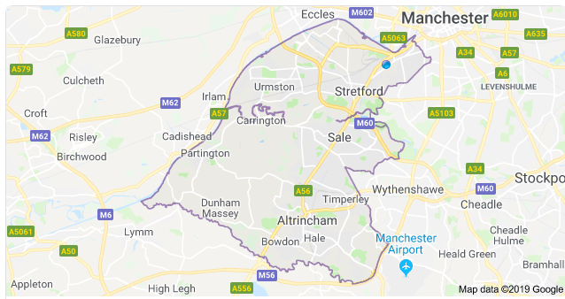

Trafford Town Hall

Trafford as a training location offers a range of exciting professional development opportunities and experiences. The registrar will be based at Trafford Town Hall in Old Trafford where the council and CCG are co-located.

In both health and economic terms, the profile of Trafford is close to that of England as a whole. The population is amongst the healthiest in the North West, but the North West is the least healthy region in the country. One of the greatest challenges in Trafford is the impact of the health and social inequalities which exist in the borough, which are often masked by Trafford’s relatively good health outcomes.

To find out more about Public Health in Trafford, including accessing the two previous annual reports please click on: https://www.trafford.gov.uk/residents/adults-and-older-people/health-and-wellbeing/public-health/Public-health.aspx . Interactive maps of the borough can be found here: https://www.trafforddatalab.io/ The Trafford JSNA is available here: http://www.traffordjsna.org.uk/

- The Public Health team in Trafford
The Trafford Public Health team is a small, friendly team, which enables registrars to undertake a wide variety of projects and really get involved with the full remit of Public Health functions. The team meets regularly to review and discuss work.

Public Health is located within an integrated commissioning team as part of the Children, Families and Wellbeing Directorate. The team currently consists of a Director of Public Health (DPH), one full time Consultant in Public Health, one part time consultant in Public health, 2 Public Health analysts, a Commissioning Support Officer and an apprentice. Public health is not restricted to just these individuals, and there is a close working relationship with other commissioning colleagues.

The team work successfully across the Partnerships to deliver public health priorities. Trafford offers an opportunity to get a wealth of different learning experiences which may not be as available if training in a large team.

- Location and transport
The Public Health team is based at Trafford Town Hall, Talbot Road, Stretford, close to the Metrolink tram stops at Old Trafford, Firswood and Trafford Bar.
Trafford Council encourages active travel, and many of the Public Health team are keen cyclists. Showers, lockers and a drying room facility are available at the town hall, as well as secure bike parking and various bike related events throughout the year.
Car parking is also available nearby.

Trafford is on the Manchester to Altrincham tram line so getting to and around the borough via Metrolink is easy. Three motorways, (the M60, M56 and M6) pass through Trafford making it easily accessible.

- Educational Supervisor
Helen Gollins, Consultant in Public Health, is the lead educational supervisor for the team. Donna Sager, Consultant in Public health, is another supervisor. Eleanor Roaf, the Greater Manchester Training Programme Director is Trafford’s interim DPH.

- Academic Links
There are strong links with Manchester University; our previous consultant Paula Whittaker is an Honorary Clinical Lecturer at the University and can arrange teaching and research opportunities if desired.

- Areas of opportunity
There are good opportunities to gain a range of experience in partnership working, early help, commissioning, community engagement, integrated working and transformation. Projects within the Greater Manchester Health and Social Care partnership are available. Registrars will be expected to undertake work with the CCG. More senior registrars can lead our work on particular topics.

- Organisation of Training
Each registrar will agree a work plan based on their learning needs, including outcomes to be achieved. There will be regular meetings between the supervisor and the registrar plus informal contact in-between as needed. Regular informal reviews of the training and progress against the Public Health learning outcomes are undertaken with support to achieve Part A and Part B of the membership exams.

- Examples of recent StR activity
One of the benefits of working in Trafford is that registrars are encouraged to undertake innovative approaches to tackling Public health issues.

Examples of work include:

- E-cigarette smoking cessation pilots
- Poverty plan development
- Social Isolation intervention review
- Work place health leadership
- Public health input into local plan development
- Suicide prevention strategy
- Gram negative bacteraemia review
- Gypsy and Traveller community health needs assessment
- Evidence review of smoking during pregnancy
- Support for the development of a partnership approach to tackling domestic abuse, focussing on perpetrators
- Work with CCG and primary care to increase bowel cancer screening rates in low uptake practices
- Involvement in a health protection recall incident
- Development of a service specification for a community engagement programme
- Community engagement to increase cervical screening uptake in BME women
- Development of a multi-agency Falls Strategy

- Facilities
All registrars will be agile workers and have access to a hot desk, laptop and locker, and are regarded as a full member of the public health team.

- Who to contact
If you are interesting in training in Trafford please contact Helen Gollins, Consultant in Public Health, tel: 0161 912 4276, helen.gollins@trafford.gov.uk.

