Wigan Borough

Public Health Training Prospectus

Introduction

Wigan Borough is located on the western edge of Greater Manchester and covers an area of approximately 77 square miles. While Wigan is the largest town in the Borough, Leigh is of similar size. There are further smaller towns and villages. Wigan Borough has a history of mining and manufacturing, and many of the towns started off as settlements to service these functions. Despite this heritage Wigan Borough has a sizable amount of green space. A map of the Borough is shown in Figure 1.

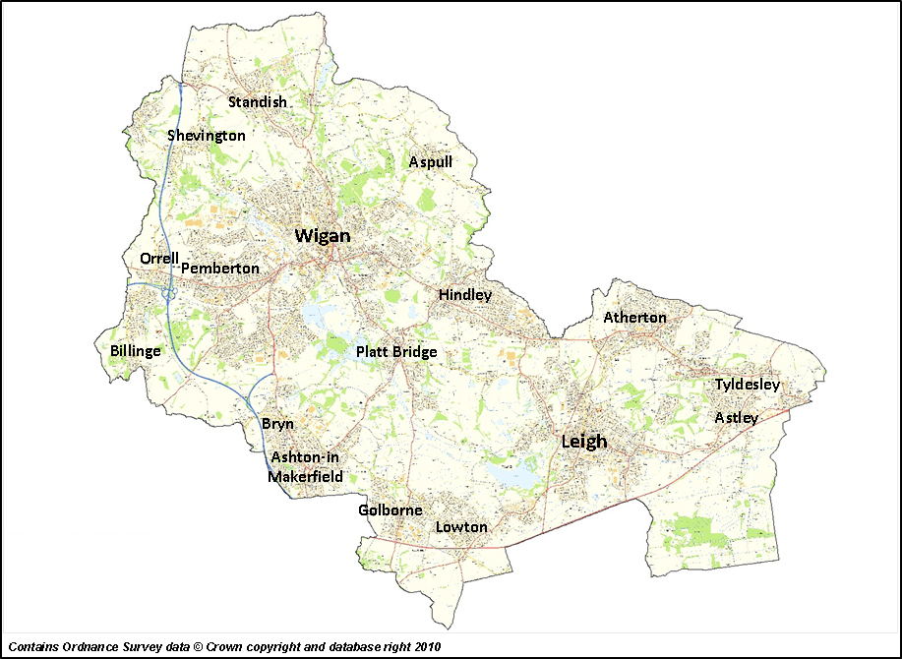
Figure 1. Main population centres within Wigan Borough

Population

Wigan Borough has the second highest population of the ten Boroughs in Greater Manchester. Its population is 320,975 (Mid-2014 ONS Population Estimates). Figure 2 shows the distribution of the population by age group at sex. Of the 200 Lower Super Output Areas (LSOAs) in the Borough 57 are in the 20% most deprived LSOAs in England. 28.6% (91,773) of the Borough’s population live in these areas.

As of the 2011 Census, over 95% of the population was White British. This compares to just under 80% in England as a whole. However, Wigan Borough has received a sizeable number of refugees and migrants over the last decade and it is likely that the population will become more diverse over the coming years.
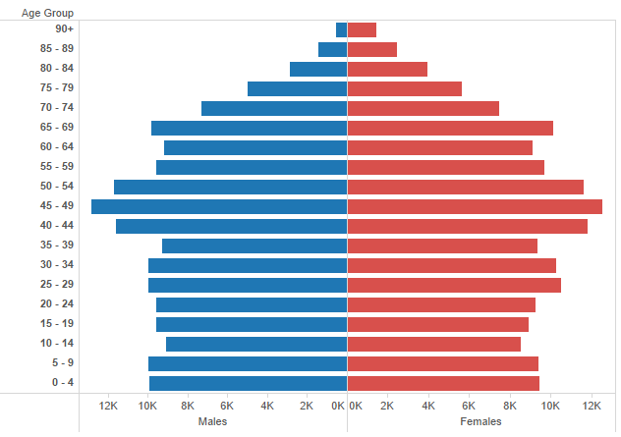
Figure 2. Population of Wigan Borough by age group and sex (Mid-2014 ONS Population Estimates)

The proportion of people aged 65+ in Wigan Borough has increased from 14.4% in 2001 to 18.1% in 2014, and is projected to increase further to 20.6% by 2025. Therefore, maintaining the health and resilience of older people is key to ensuring the sustainability of local health and adult social care services.

Health

The good news is that the health of the people in the Borough is improving. Life expectancy is increasing and mortality from cardiovascular disease in people aged under 75 has halved over the last decade. However, despite this improvement there remains a gap between the Borough and England as a whole. In addition, there is wide inequality in health within the Borough. Much of this can be explained by historically high levels of smoking (around 30% in 2000, now 20.6%), poor diet and lack of exercise. The health effects due of the Borough’s industrial past are still present but are receding.

Public Health in Wigan Council

With the dissolving of Ashton, Leigh and Wigan Primary Care Trust the local public health workforce transferred to Wigan Council in April 2013. Within that first month Wigan Borough was identified as a ‘hotspot’ for measles in England. This resulted in local and national media interest including a television appearance. However, it provided an excellent opportunity to showcase our heath protection capability that had been developed over a number of years, and thus gain immediate credibility within the Council. We continue to have an active and experienced Health Protection Team.
As elsewhere in the country, the public health workforce has had to adapt in its new environment and to financial pressures. Therefore, there have been many changes in the last three years. Public heath has been incorporated into the Council’s Peoples Directorate within which the life course approach has been adopted. This has giving rise to three teams, Start Well, Live Well and Age Well.

Key to improving health and wellbeing within the Borough has been a strong move to an asset based approach where we concentrate on what people and communities have and can do rather than perceived deficits. It involves working with residents to find solutions rather than simply doing things to people. This has not only provided a means to improve the relationship of residents with the Council but has also helped meet local financial challenges. This approach is characterised locally as ‘The Deal’. This developed in recognition that the Council could not provide all the services that it had in the past and that a more equal relationship between residents and the Council would provide a better foundation for improving health and wellbeing within the Borough. Further information is available via the links below:

www.wigan.gov.uk/Council/The-Deal/The-Deal.aspx

www.wigan.gov.uk/Council/Strategies-Plans-and-Policies/Deal-for-the-future.aspx

Public Health Training Opportunities

Wigan Borough has not trained specialty registrars (StRs) since 2008. However, tutorials and revision sessions have been provided to pre-part A StRs covering statistics, epidemiology and health information on request during the last six years.

Wigan Borough provides many opportunities for StRs to learn by engaging in the work to improve health and wellbeing in the Borough, see examples below (not exhaustive).

- Start Well

- Under 5s
- School readiness
- Safeguarding children

- Live Well

- Improving diet
- Reducing overweight and obesity
- Encouraging exercise
- Prevention of key diseases – diabetes, cardiovascular disease cancer
- Suicide prevention

- Age Well

- Falls in the 65+ age group
- Fuel poverty
- Adult social care

- Areas transcending the life course

- Drugs and alcohol
- Sexual health
- Asset based approach and ‘The Deal’
- Public health intelligence
- Joint Strategic Needs Assessment (locally branded as ‘Our Borough Story’)

- Health Protection

- Management of communicable disease outbreaks
- Severe weather response (e.g. the recent floods)
- Management of environmental incidents
- Infection control

Audit

In addition to the above, there are also opportunities to engage in audit. Recent examples include:

- Suicide audit using coroner’s records. Wigan Borough has had a high incidence of suicide in males though there are signs that it is now reducing.

- Infection control, immunisation and communicable disease audit:

  - Care homes (in conjunction with Wigan Council Quality Team)
  - Nurseries (in conjunction with Wigan Council Early Years Team)

- Tattoo establishments – infection control audit

Workspace

Wigan Council operates an agile working policy. Therefore, no one has a designated desk including the Chief Executive and the Director of Public Health. However, teams do tend to occupy specific areas in order to work together. This has largely come about organically though there are specific areas for some teams such as the Joint Intelligence Unit. To complement agile working there is a clear desk policy. Agile working includes the opportunity to work from home via a virtual private network. Most of the workspace is open plan that is complemented by meeting rooms and break out areas. The latter can be used for small impromptu meetings and refreshments.

