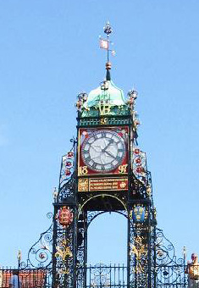
PUBLIC HEALTH TRAINING PROSPECTUS

Cheshire West and Chester Training Location

Why choose Cheshire West and Chester (CW&C)?
- CW&C covers a varied resident population, providing STRs with a wide range of opportunities.
- STRs will be based at the new local authority ‘HQ’ building in the centre of Chester. It provides offers a pleasant physical environment with excellent facilities and support.
- Trainers at Cheshire West and Chester have extensive training experience.

INTRODUCTION

  - Cheshire West and Chester
Cheshire West and Chester has a population of approximately 330,000 residents and covers 350 square miles. The borough is located in the North West of England and includes the historic city of Chester, the industrial town of Ellesmere Port and the market towns of Frodsham, Helsby, Neston, Malpas, Northwich and Winsford. There is a wide range of manufacturing industry (chemical and engineering), a large agricultural base, a strong service sector plus a vibrant leisure and tourism sector, highlighting the dramatic contrast between acres of rolling Cheshire plain, lush forest, tall chimney stacks and towering industrial landscapes. About a third of the population live in rural areas. Most population health outcomes for the local population are similar to the national average but this hides patterns of stark health inequalities According to the government’s ‘Indices of Deprivation’, the overall quality of life is good for many residents; however, there are places where some communities experience multiple disadvantages.

  - Our Population
Cheshire West and Chester has a population of approximately 330,000 residents. The number of people living in Cheshire West and Chester has, in general, shown a modest growth over the past 25 years. The population in 2009 was 326,600. We expect this to increase to 352,800 by 2029. Overall, this would be a greater growth than seen in the past. We have a lower proportion of under 20s compared to national rates and this is expected to continue to fall until 2015, then starting to increase again. The population of Cheshire West and Chester has an ageing profile, with the number of residents aged over 65 expected to increase by over 50 percent by 2029 and those over 85 to more than double.

1.3 Cheshire West and Chester Council
Cheshire West and Chester Council is a top performing council in the country with many national awards to its’ name.
Council website - http://www.cheshirewestandchester.gov.uk/
The Vision of the council is ‘to be the best’. Public Health are fully integrated into the council and are aspiring to the best PH team in England.
Council Vision - The Corporate Plan for CW&C 2011-2015 “Altogether Better” is found at http://www.cheshirewestandchester.gov.uk/your_council/policies_and_performance/council_plans_and_strategies.aspx
Vision Wheel pictorial – pages 6 and 7
http://intouch-org.temp.connectedcheshire.org.uk/wp-content/uploads/2013/03/index.html#/8/

- ORGANISATION OF TRAINING

There is a wide range of opportunities to work in multi-disciplinary teams on particular projects or roles at an appropriate level of responsibility. A balanced portfolio of training opportunities and specific responsibilities is negotiated before and during the placement, using the e-portfolio as appropriate.
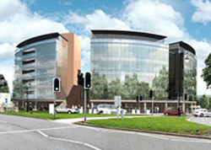
2.1 Location and Facilities
The transition has seen the Public Health team moving to the newly built HQ, Chester and Western Cheshire Council Offices, which is within walking distance of Chester City Centre. The location is approved by the Faculty of Public Health for 2 trainees.

A Park and Ride system operates into the city, and is free of charge to employees based at HQ who do not live in Chester Centre (a cut off zone applies). Additional car parking is also available, both short stay and long stay (based on a daily rate). There is also a free bus service from Chester Railway Station in to the city centre.
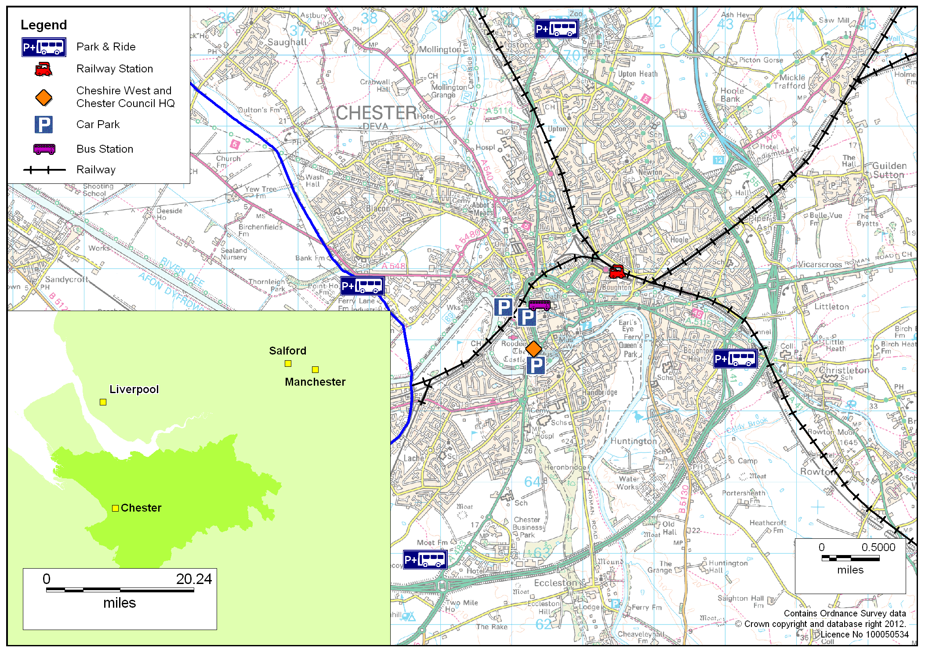
Address
Organisation | Address
HQ - Cheshire West and Chester | 58 Nicholas Street, Chester, Cheshire. CH1 2NP
2.2 Structure of the training
Lead Trainer | Details
Caryn Cox FFPH | E-mail Address: caryn.cox@cheshirewestandchester.gov.uk

Each STR is allocated an educational supervisor; this person keeps an overview of their training needs throughout their time in the training location. STRs can expect regular meetings with their Educational Supervisor. All trainers have extensive training experience.

When STRs start in the location they discuss their training needs with their educational supervisor. Each trainee undergoes an induction programme to meet key people and find out about public health in the area, which will include other consultants and team members who will be involved in their training.

Other trainers may supervise a particular project, and people who are not accredited trainers may also be involved in delivering specific training in areas where they have expertise.

2.3 What to expect?
All STRs are encouraged to fully participate in the working life of the Public Health Team. All trainers are committed to building capacity and skills through CPD events and participation in the regional ‘training the trainers’ programme.

We have an excellent track record in working with the local authority, and the transition of Public Health will provide exciting challenges and opportunities. We have traditionally had strong links with the University of Chester, and there is now an opportunity to develop these links further.

- FROM THE STR’s PERSPECTIVE
3.1 Examples of Trainee’s Projects
Recent examples under the three domains of public health practice include:
Health Improvement
- Self Harm – Joint Strategic Needs Assessment
- Rapid health impact assessment of Chester at Night strategy
- Joint Strategic Needs Assessment for families living on the Dale Barracks
- Suicide audit and recommendations for actions arising

Health Protection
- Developing the strategy for management of people with Hepatitis C
- Lead responsibilities for Vaccination and Immunisation programmes
- Review of Hepatitis services

Health Service Delivery and Quality
- Local implementation of the National Bowel Cancer Screening programme
- Introduction of the Cardiff Model, to reduce the incidence of assault and emergency department attendances
- Health Inequalities – management of the National Support Team visit
- Representative for Public Health at the Clinical Commissioning Group’s Quality Group.
- Analysing and producing the Local Safeguarding Children’s Board 4 year update report on child deaths
3.2 What the STRs say?
Comments from previous trainees:

"A great training location; this is one of the few locations where I felt valued as a member of staff rather than just a trainee."

"… is in a great position, it is easy to get to, a nice place to be and offers some really interesting work opportunities due to the diversity of the patch it covers. A really rich learning opportunity all round."

“During my time I was given some good opportunities, and managed to achieve quite a number of competencies. Examples of work include setting up the Bowel Cancer Screening programme, and conducting a sexual health skills audit, and writing the emergency plan."
"… is great for trainees in the later stages of the training scheme, as you can often be given the opportunity to lead on areas of work."

"It was a smaller team than I was used to, but I everyone was very friendly and helpful - particularly my trainer, who I enjoyed working with and was very supportive and approachable"

USEFUL LINKS

JSNA (known as the ISNA)
http://www.cheshirewestandchester.gov.uk/your_council/key_statistics_and_data/jsna-1.aspx

Annual DPH Report
A groundbreaking report was produced in 2013 “ A year in the life of Public health” which was ‘fully public facing’ and did not contain a single graph or chart. The report takes people through a calendar year and highlights the key public health issues facing residents in CW&C that need tackling but framed in a way that supports people to make changes in their own lives.
A separate compendium of statistics accompanied this along with signposting people to the iSNA for supporting data.
http://www.cheshirewestandchester.gov.uk/your_council/key_statistics_and_data/annual_public_health_reports.aspx

Health and Wellbeing Board
The Board meets bi-monthly and also hosts a separate additional wider partnership meeting involving a wide range of additional key partners who are key to delivering together improved health and wellbeing across CW&C.
Health and Wellbeing Board – minutes and reports
http://cmttpublic.cheshirewestandchester.gov.uk/ieListMeetings.aspx?CId=935&Year=2014

Altogether Better community budget programme
In 2012-2013 CW&C was one of four Community Budget pilots. The programme was about real and lasting change. It involved reviewing local public services and partner organisations in the public, private, voluntary and community sector. Together we aim to tackle the root causes of longstanding problems, promoting early intervention and deploying resources in the most effective way. Too often public services react and respond, serving local problems, rather than solving them.
Altogether Better promotes new delivery models of services that are both innovative and effective. This opportunity captured West Cheshire’s ambition to deliver efficient and customer focused services across a range of local partners.
The 6 key areas covered are
- Families Together
- Early Support
- Work Ready Individuals
- Safer Communities
- Ageing Well
- Integrated Assets

http://www.altogetherbetterwestcheshire.org.uk/

Integration Pioneer status
In November CW&C along withCheshire East and other partners submitted and were successful as one of 14 Integration Pioneer programmes.
Public Health are part of this programme as prevention is a key area to tackling issues at an earlier stage before they escalate to more costly crisis services.
https://www.gov.uk/government/news/integration-pioneers-leading-the-way-for-health-and-care-reform--2

Other links
http://www.cheshirewestandchester.gov.uk/your_council/key_statistics_and_data.aspx

Council Vision
The Corporate Plan for CW&C 2011-2015 “Altogether Better” is found at http://www.cheshirewestandchester.gov.uk/your_council/policies_and_performance/council_plans_and_strategies.aspx
Vision Wheel narrative
http://intouch-org.temp.connectedcheshire.org.uk/?p=741
Vision Wheel pictorial – pages 6 and 7
http://intouch-org.temp.connectedcheshire.org.uk/wp-content/uploads/2013/03/index.html#/8/

Twitter - @DPHcheshirewest

Reviewed: Feb 201, Caryn Cox, Public Health

